

Table of Contents

Introduction and Context 3

Project Briefing 3

Business Problem 3

Analytical Framework 3

Limitations 4

Analytical Exploratory Analysis 5

Data Cleaning Process 5

Exploratory Analysis & Preliminary Insights 7

Exploratory Analysis & Trends 7

Linear Relationships & Clusters 8

Data Distribution 10

Data Modeling 11

Final Regression Predictive Model 11

Approach 11

Clustering 13

Classification 14

Reviews & Summaries Analysis 15

Products 15

Categories 16

High-Loyalty Customers 17

Global Sentiment Analysis 18

Recommendations & Next Steps 20

Recommendations 20

Loyalty Program Future Health Check 20

Appendix 21

Five Whys Framework: 21

Data Distribution 22

Future Models – To Investigate 48

Natural Language Processing 50

Works Cited 55

# Introduction and Context

## Project Briefing

Turtle Games, a game seller and manufacturer, aims to increase its overall sales by leveraging insights drawn from the analysis of its customer base and the loyalty program scheme.

## Business Problem

Turtle Games commissioned the analysis, aiming to cover the following areas:

* Exploratory analysis of the customer demographic data
* Analysis of spending and annual remuneration trends and their relation to loyalty points accumulation.
* Customer segmentation to identify high and low return customers
* Predictive Modeling including:
  + A classification model to predict customer segment membership
  + A regression model to estimate the accumulated loyalty points
* Sentiment Analysis of customer reviews and summaries, focused on:
  + Products
  + Product categories
  + Global sentiment patterns across all reviews and summaries

## Analytical Framework

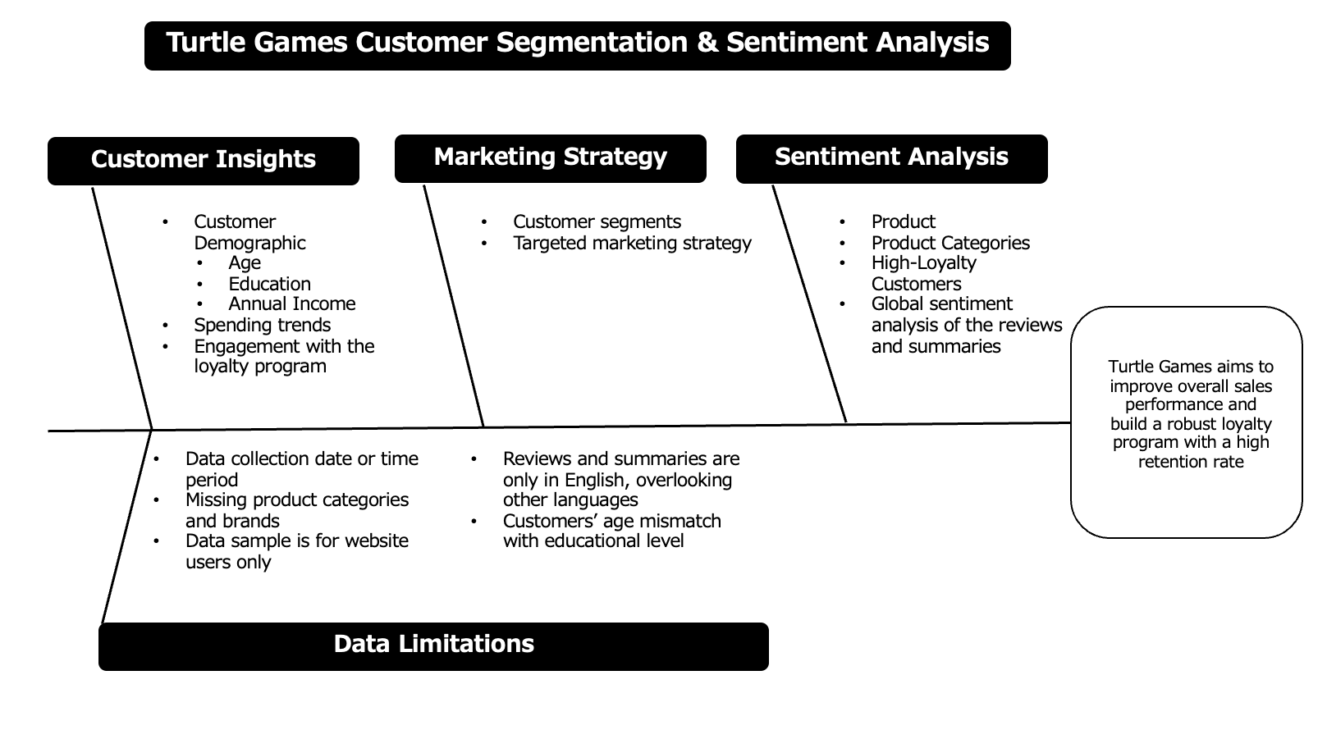

## Limitations

* Timeframe of the data collection is not identified
* Data sample is for website users only, overlooking app users.
* Only English reviews are analyzed, overlooking reviews in other languages

# Analytical Exploratory Analysis

## Data Cleaning Process

* Customers were grouped both by demographic and behavioral variables –resulting in 782 unique customers.

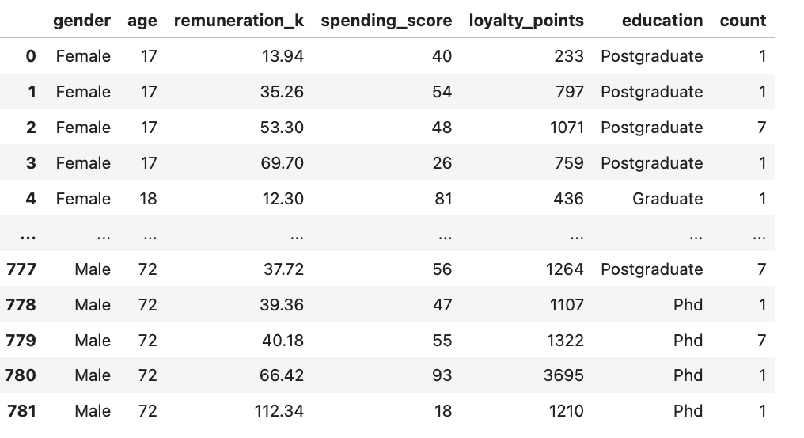

* Inconsistencies in the age and education of some customers were identified 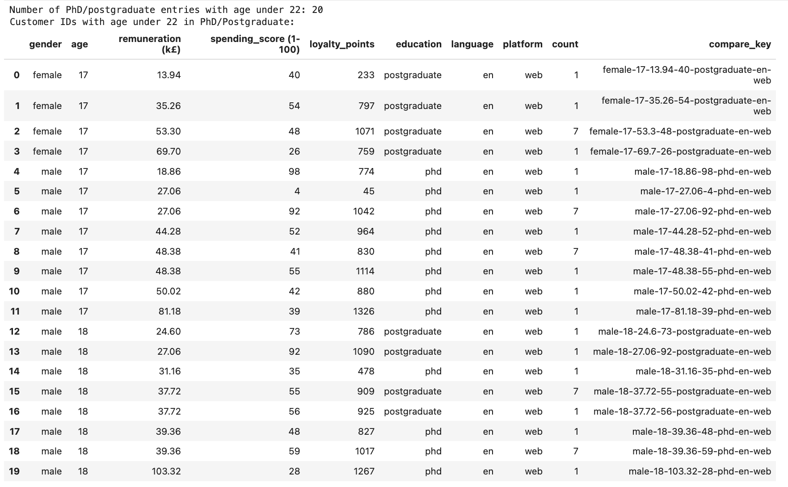
* Unique customer IDs were assigned to the identified individual customers.
* 3 Mistakenly copied reviews were identified and were excluded from the sentiment analysis.

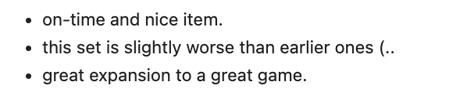

## Exploratory Analysis & Preliminary Insights

### Exploratory Analysis & Trends

83.12% of the customers have between 0-2000 loyalty points, which strongly indicates low customer engagement with the current loyalty program.

Only 0.77% have above 6000 points. 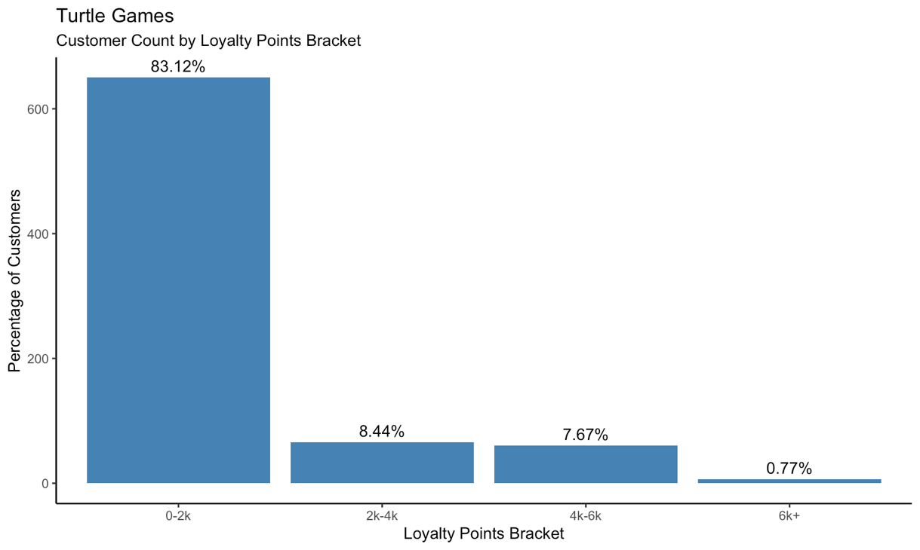

Almost 33% of the customer base has a spending score of 40-60, followed by 19.89% in the 0-20 spending score range.

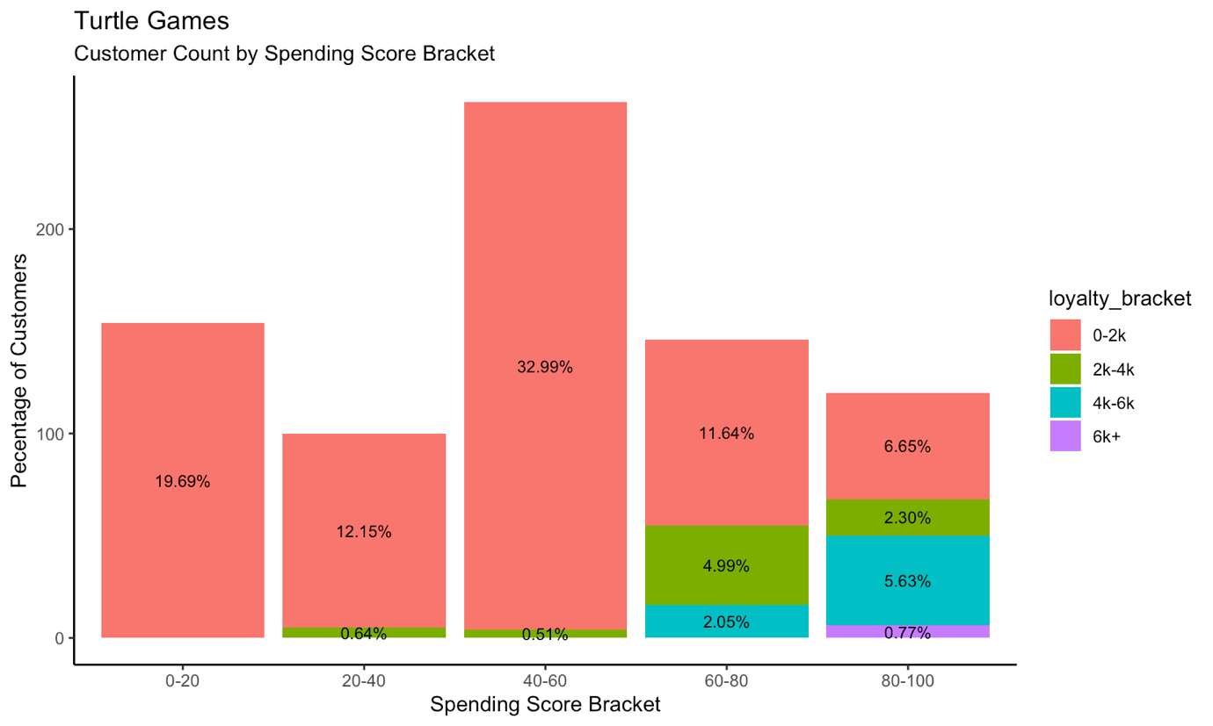

### Linear Relationships & Clusters

A linear relationship between loyalty points, spending score, and annual remuneration was identified. This signifies that increases in spending score and annual remuneration are associated with an increase in loyalty points.

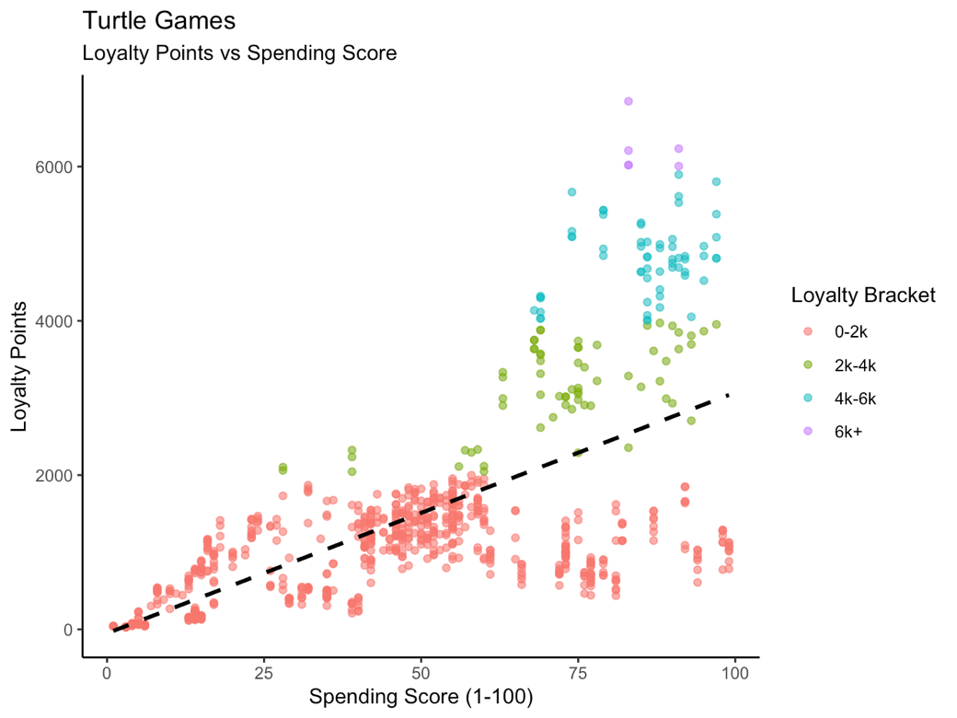 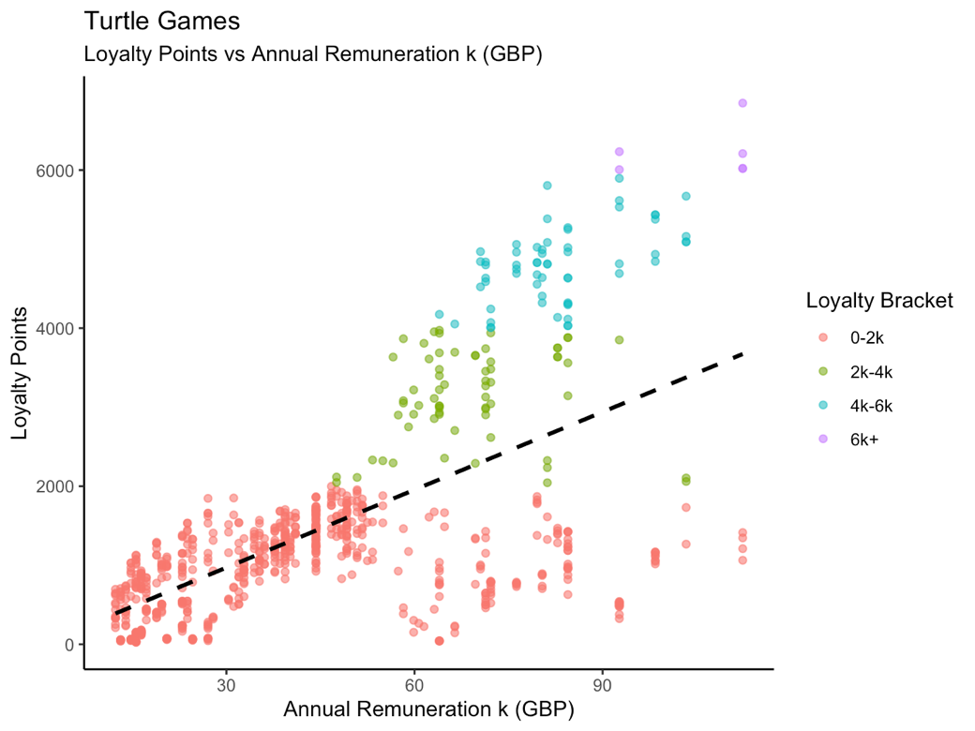

Data point clusters were identified on the spending score vs annual remuneration plot, which strongly suggested that there are customer segments in the data.

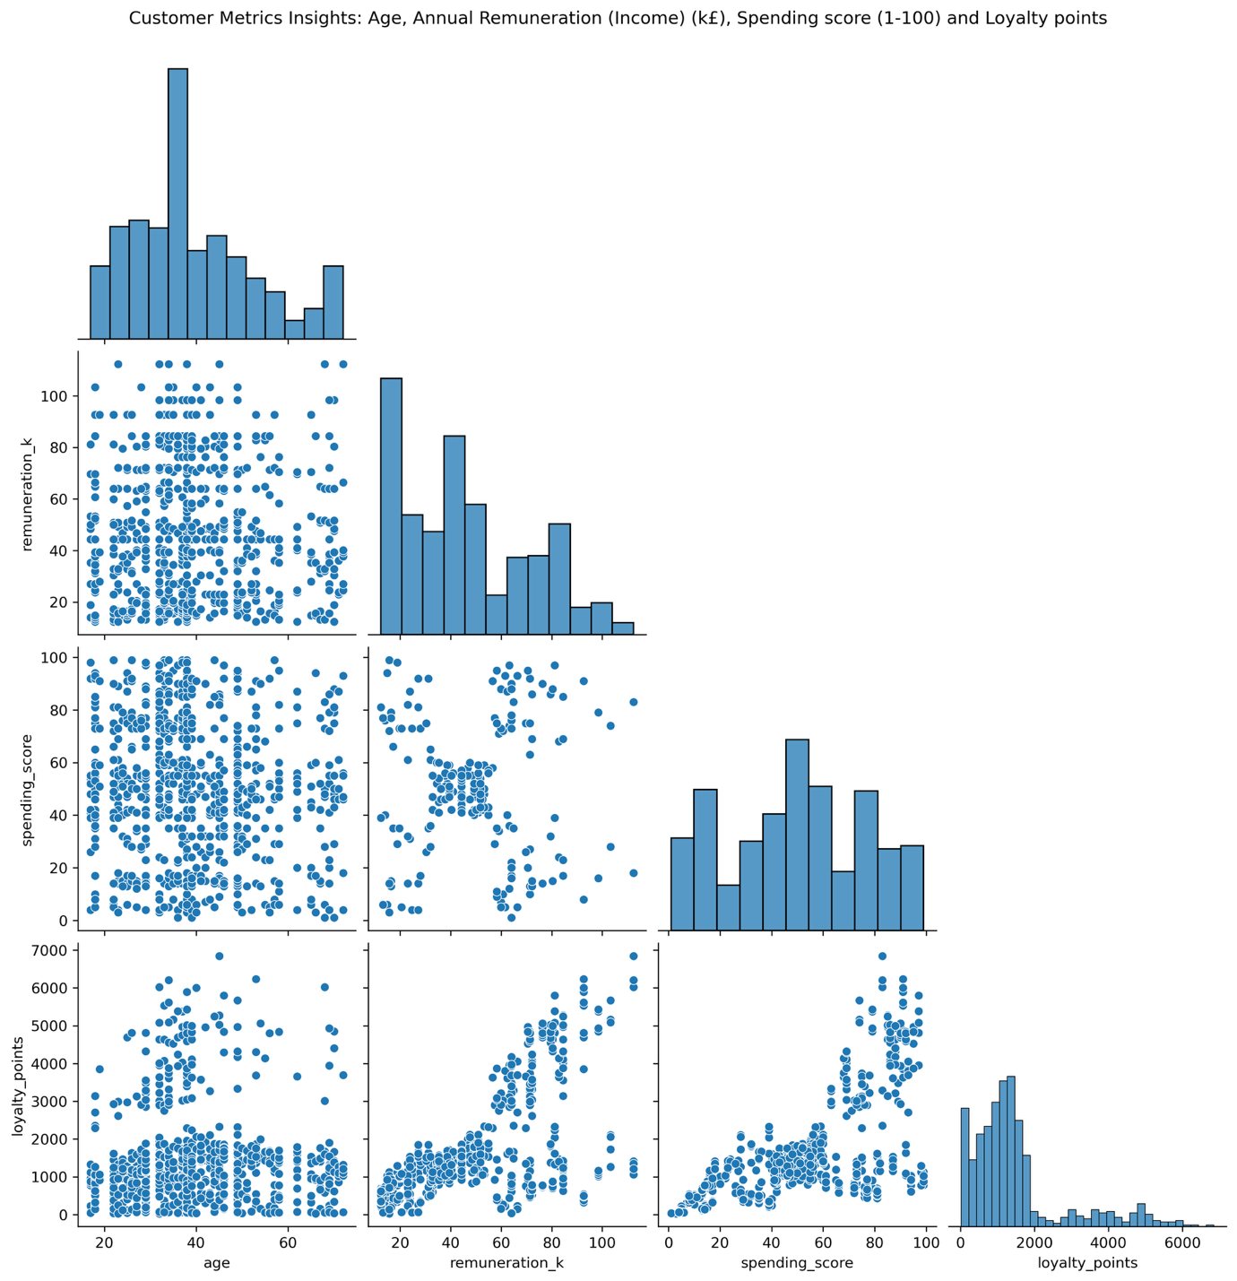

### Data Distribution

The distribution of loyalty points is right-skewed, with a heavy concentration of loyalty points accumulation below the 2000 points mark. Since linear regression models assume residuals are normally distributed, a right-skewed dependent variable can lead to non-normal residuals.

The data was deemed not suitable for linear regression models, even after transforming the loyalty points and scaling the independent variables (see Appendix).

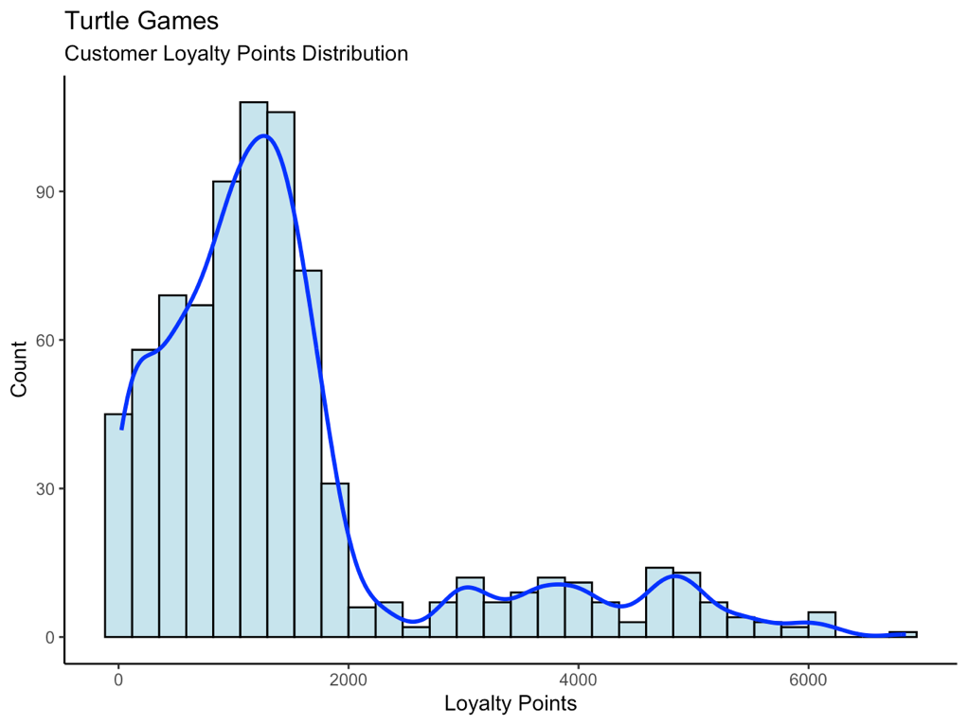

# Data Modeling

## Final Regression Predictive Model

### Approach

The importance of the independent variables was calculated, and factors with low importance were excluded to reduce noise and streamline the model.

The final model was built using the spending score and annual remuneration as these features showed the highest predictive power for loyalty points. No scaling was applied as it’s not required for a random forest regressor using the Scikit-learn library (1).

**Random Forest Predicted vs Actual Values Chart**

The red line represents the perfect predictions; the closer the points are to this line, the better the model’s predictions.

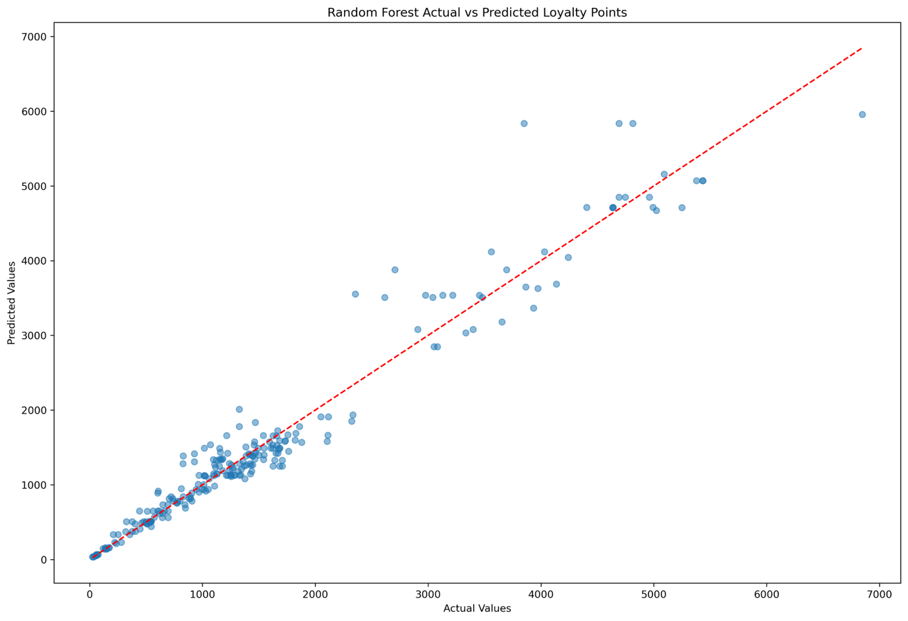

**Random Forest Regressor Results**

Given the spending score and annual remuneration of the customer, the model can predict 94.95% of the variability in the loyalty points.

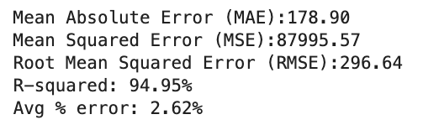

## Clustering

To identify the clusters within the annual remuneration and spending scores, a hierarchical clustering model was considered, as it helps reveal the optimal number of clusters. It’s, however, sensitive to unscaled data, so scaling had to be implemented to guarantee the accuracy of the model.

The model identified 5 clusters as shown below:

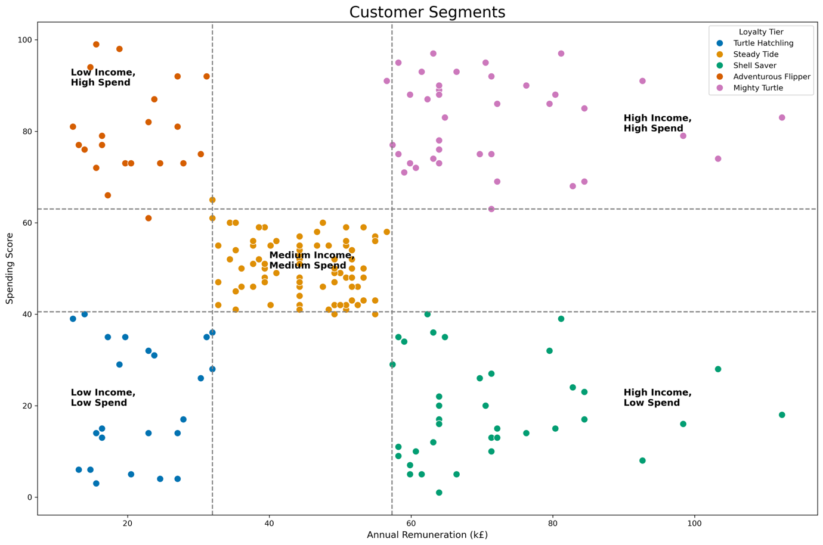

Medium Income/Medium Spend is the cluster with the highest percentage.

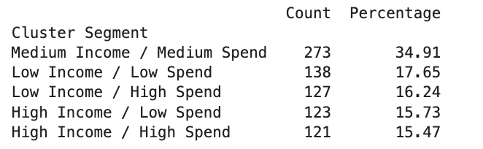

This highly suggests the need for a tiered loyalty program to cater to the needs and status of the different segments.

## Classification

To proactively assign a loyalty program tier to new customers and accordingly adapt marketing efforts, a classification model was built to classify new customers based on their spending score. This model has an 85% accuracy with the following precisions in predicting the different segments:

* Low Income / Low Spend 🡪 71%
* High Income / Low Spend 🡪 69%
* High Income / High Spend 🡪89%
* Low Income / High Spend 🡪87%
* Medium Income / Medium Spend 🡪 96%

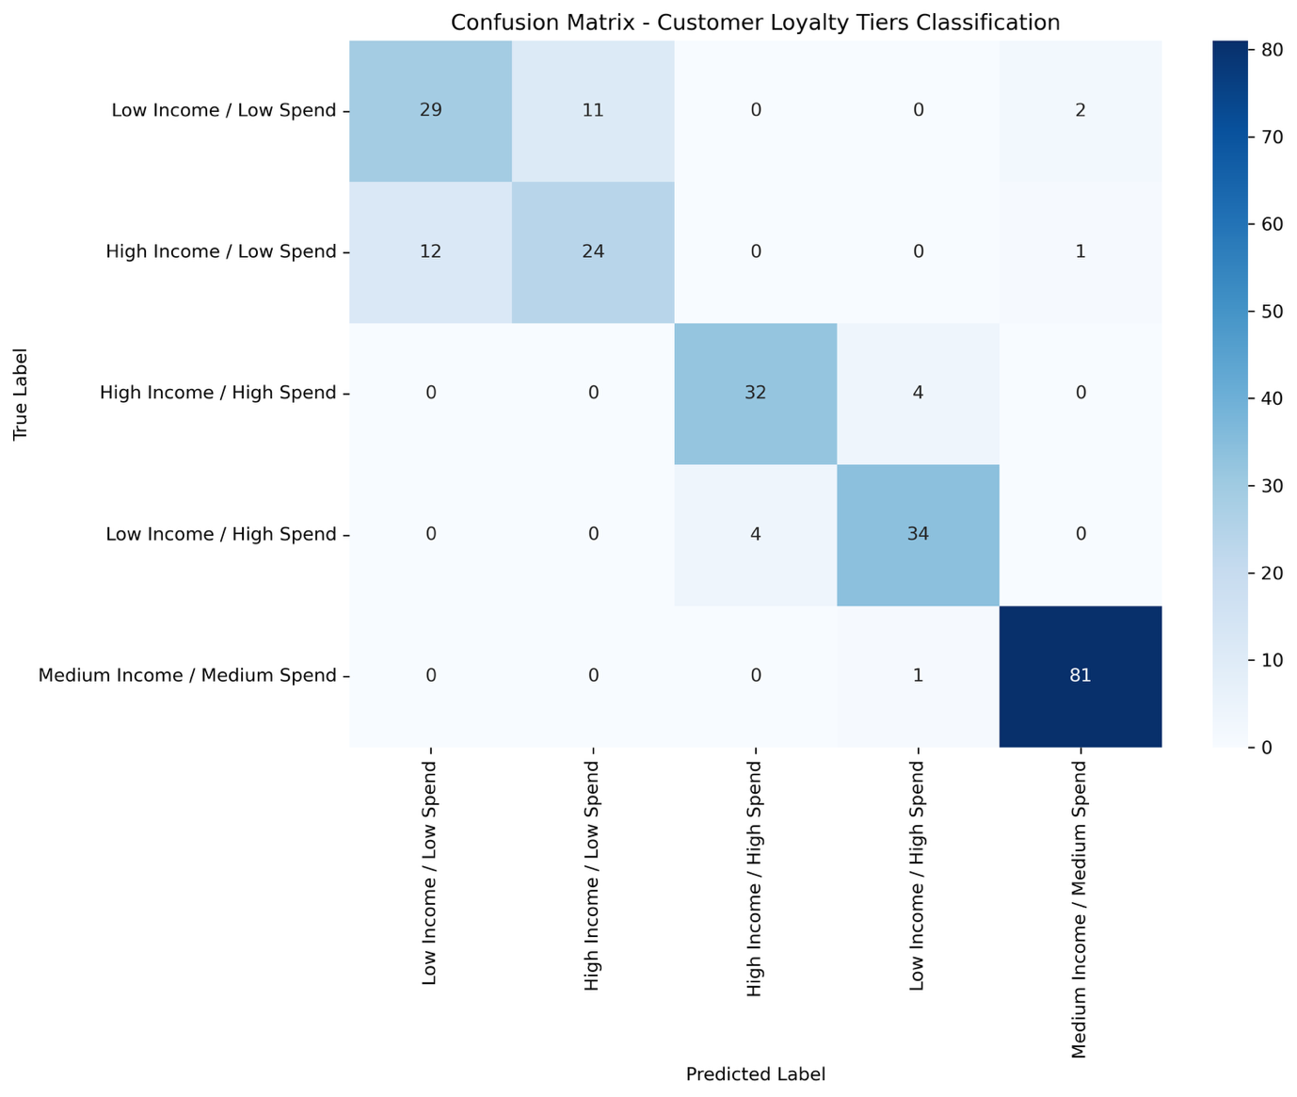

All High-Spend segments can be predicted with a precision of above 87%, which is satisfactory.

# Reviews & Summaries Analysis

## Products

Product reviews have a generally positive sentiment.

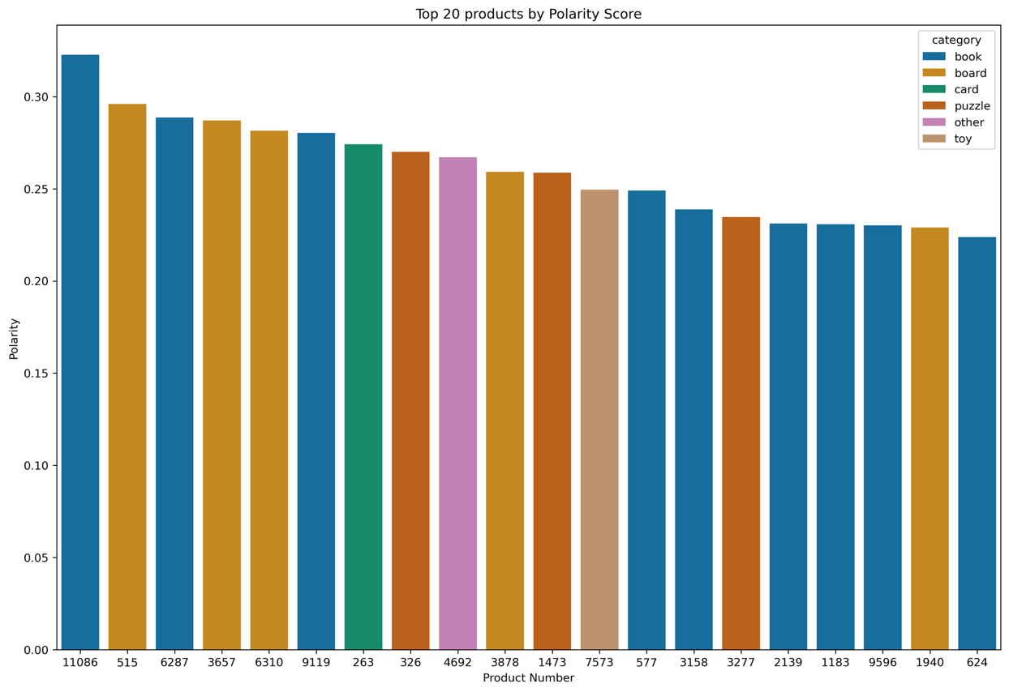

This is except for two products: **6431 & 9597**

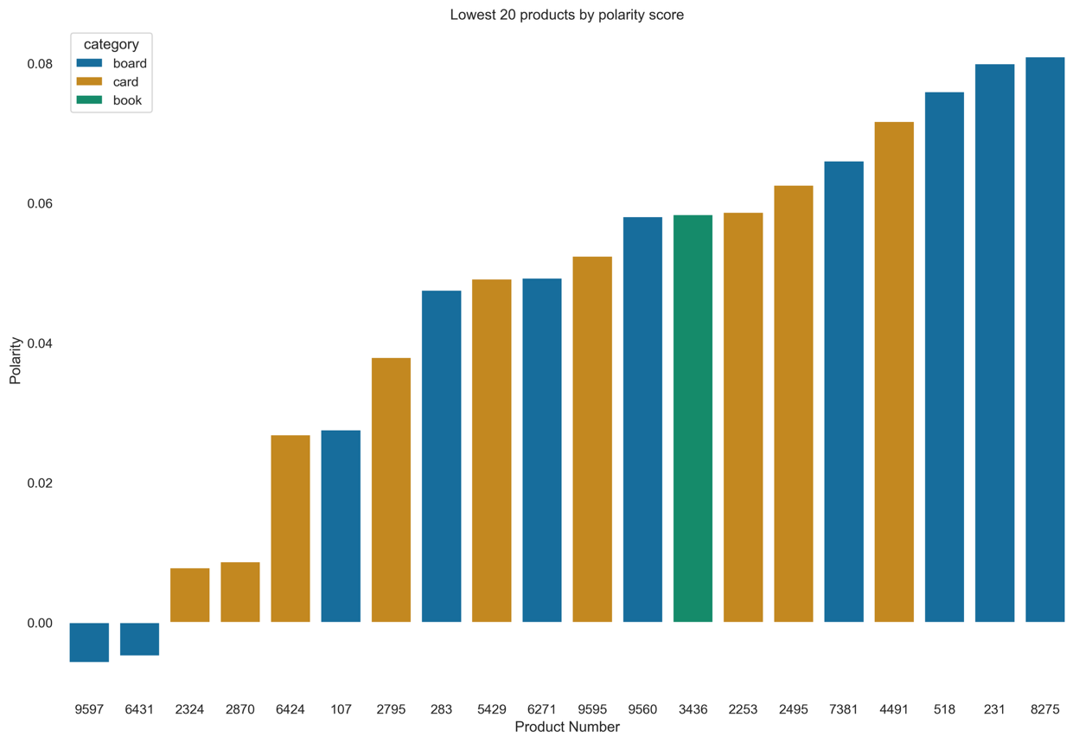

## Categories

Categories were assigned to the products using a document term matrix by assigning the category with the highest keyword count. There are limitations to this technique as it is based on the number of keywords in product reviews, but was still considered insightful.

The median sentiment score was calculated and aggregated for each category. The toy category showed slightly higher sentiment scores, suggesting that toy reviews can be more emotionally expressive, due to their association with children.

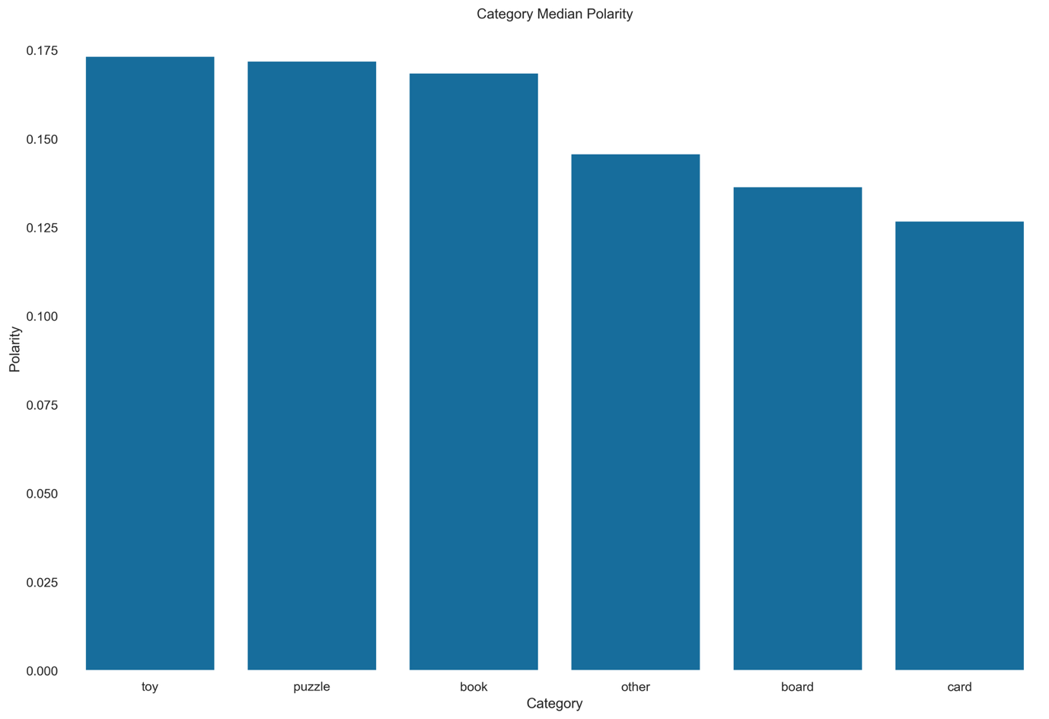

## High-Loyalty Customers

Filtering the data to only include customers with >= 4000 loyalty points, two insights were uncovered.

There are 2 customers (334 & 492) whose reviews scored high positive polarity, who could be approached to become brand ambassadors or further engaged with exclusive events and perks.

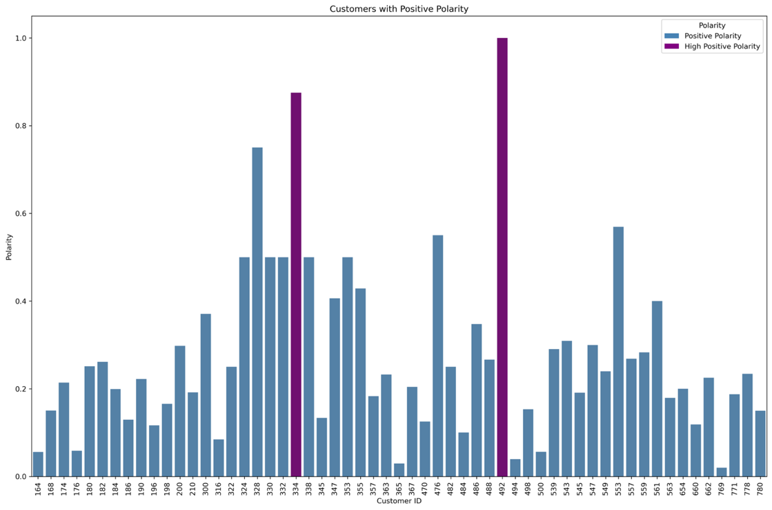

There are, however, 8 customers in this high loyalty bracket, whose reviews have negative polarity and who are at risk of churning. Their concerns should be proactively addressed to minimize that risk.

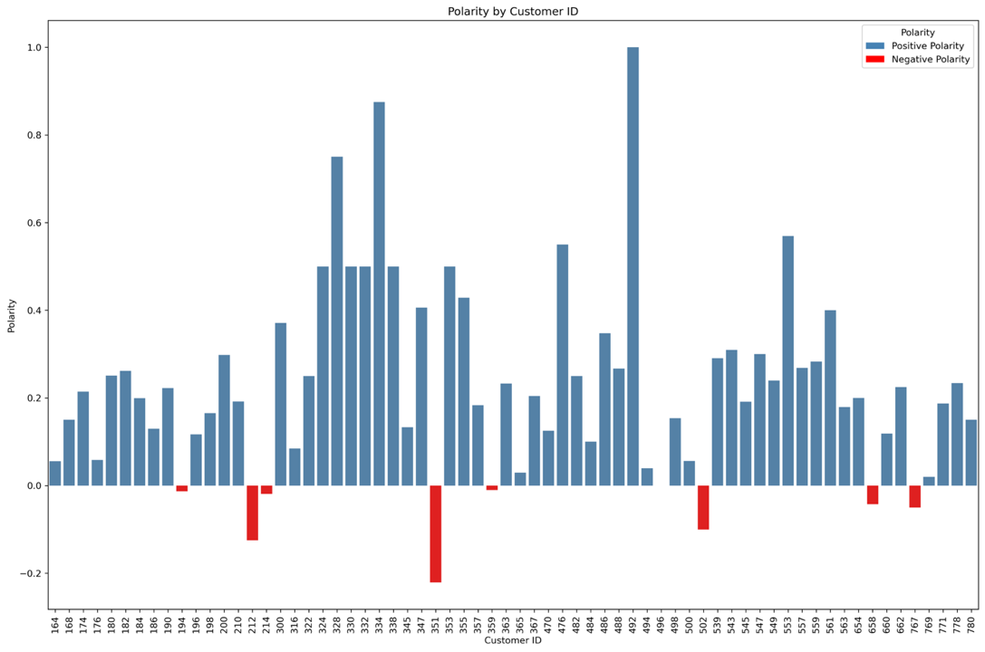

## Global Sentiment Analysis

The reviews’ word cloud was mostly dominated by subjective words such as game, card, play… etc. 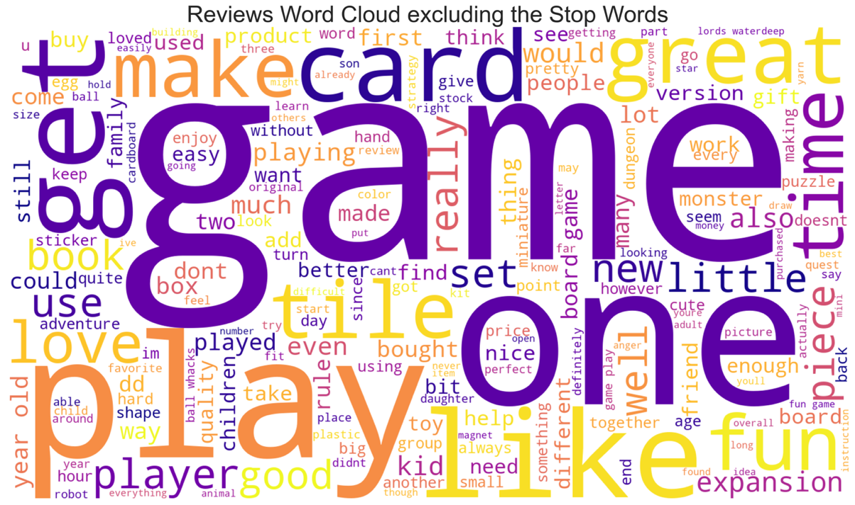

This was also confirmed through the sentiment score histogram, which shows the highest density for 0.2 sentiment scores. This shows that reviews are not dominated by strong opinions or emotions.

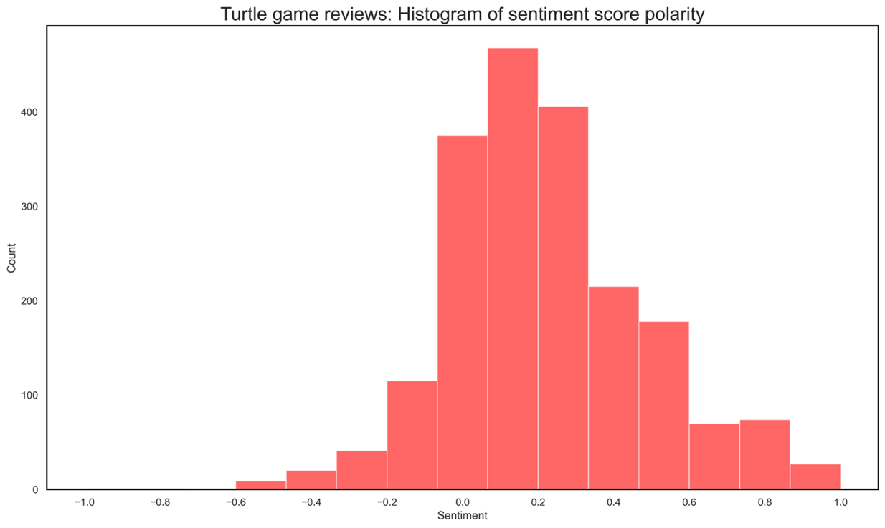

Checking the subjectivity score, we can also confirm that most reviews are a mix of facts and opinions.

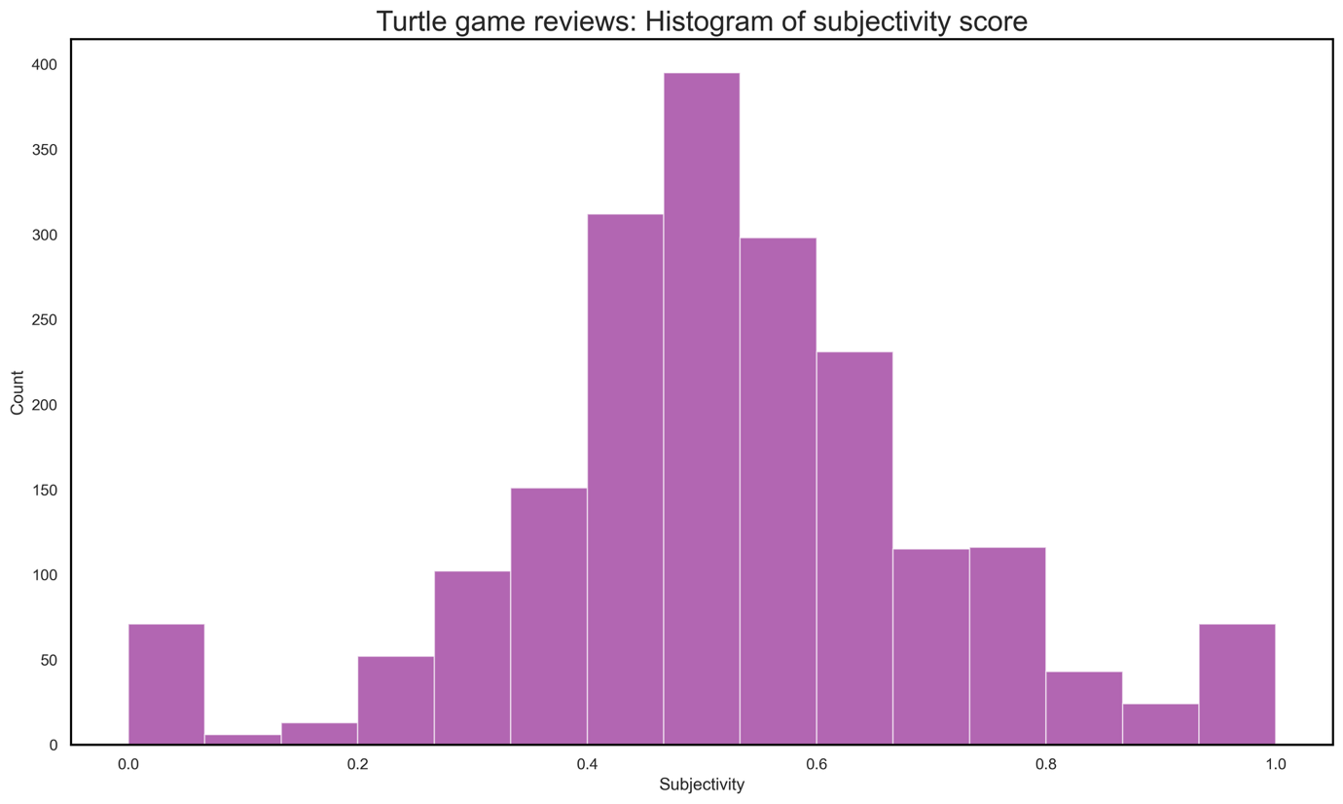

# Recommendations & Next Steps

## Recommendations

* Build a tiered loyalty program that rewards high-value customers (2)
* Proactively assign new customers to their corresponding segments using the classification model with an accuracy of 85% for better target marketing.
* Provide loyalty-based discounts for the medium income / medium spend (~34% of the customers) to encourage retention and higher sales (3).
* Proactively address high-loyalty customers with negative sentiment to reduce the risk of losing them, as 45% of customers are likely to churn when their concerns are not addressed promptly (4)
* Leverage High-loyalty customers with high positive sentiment as brand ambassadors.
* Investigate the reason behind negative reviews on products 6431 and 9597.

## Loyalty Program Future Health Check

* Check the sales and loyalty program performance (5) quarterly
* Recheck the Customer segments a year after the analysis to account for changes

# Appendix

## Five Whys Framework:

Turtle Games aims to understand its customer base and its loyalty program scheme.

**Why does Turtle Games want to understand its customer base and its loyalty program scheme?**

To be able to invest in a targeted marketing strategy to reach their high-return customers

**Why is Turtle Games considering a targeted marketing strategy?**

To avoid overspending on low-return customers and focus on better engaging high-return customers through exclusive events and valuable perks.

**Why does Turtle Games want to focus on its high-return customers?**

Satisfied high-return customers can function as brand ambassadors and can also be drivers for increased positive sentiment around the brand’s products.

**Why is it useful to leverage high-return customers as brand ambassadors?**

This would help maximize the benefits of the marketing strategy and improve the overall sales performance

**Why is it important for Turtle Games to improve its overall sales performance?**

Because, as a retailer of other brands, Turtle Games aims to build a reputable portfolio of products and brands that would make it stand out against the competition as a market leader in that segment.

## Data Distribution

#### Histograms

Both the annual remuneration and spending score distributions are multimodal. The multiple peaks in the distribution strongly suggest that there are subgroups within the data that have different trends and behaviors.

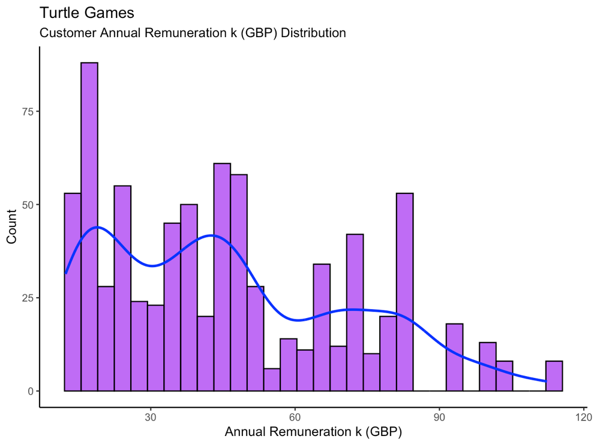 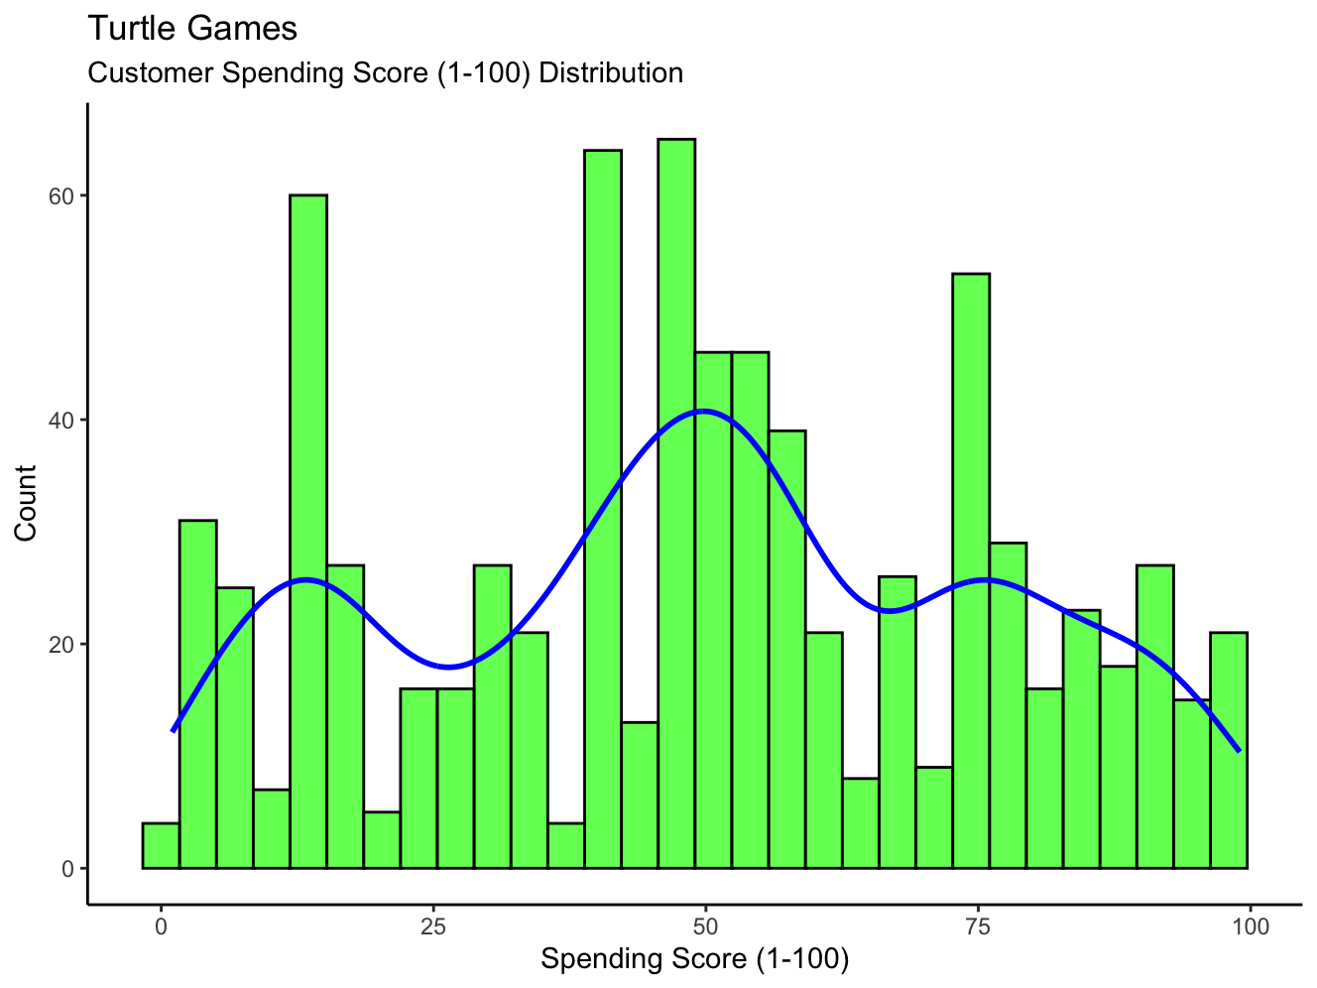

#### Violin Plots – Customer Demographic

##### Age Distribution

Male customers dominate the younger and older age groups, while female customers are more concentrated in the age bracket between 30 – 50 years of age.

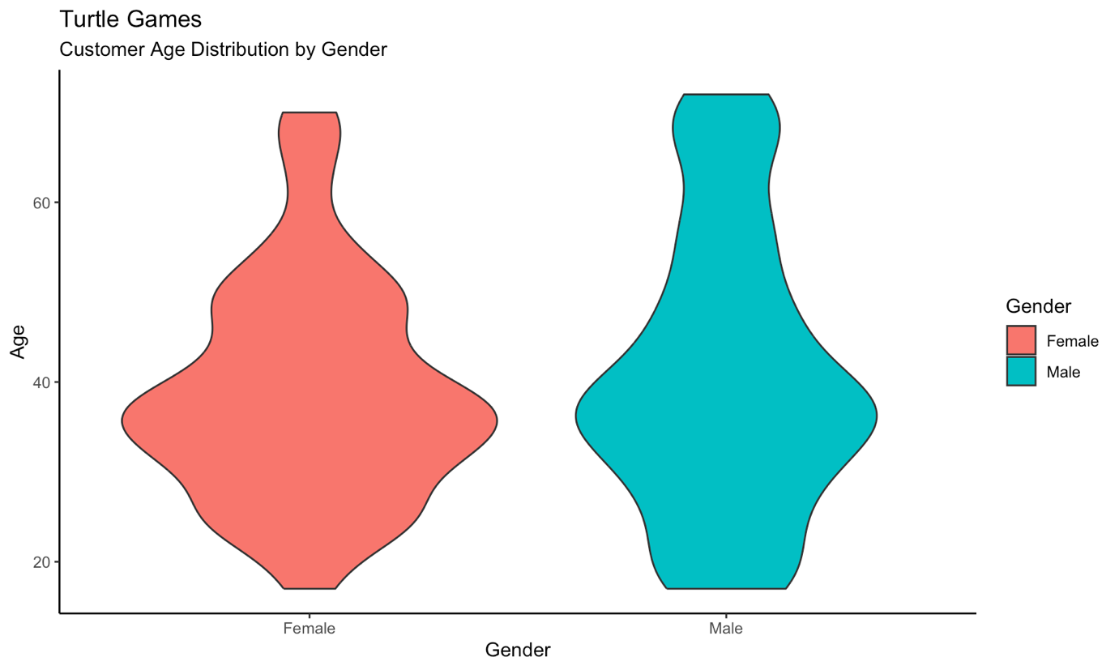

The data is showing very young customers with Graduate, Postgraduate, and Phd degrees. These will be highlighted to Turtle Games as a data quality issue. Although they seem highly illogical, these data points are not statistical outliers as confirmed by the boxplot and the IQR calculation. 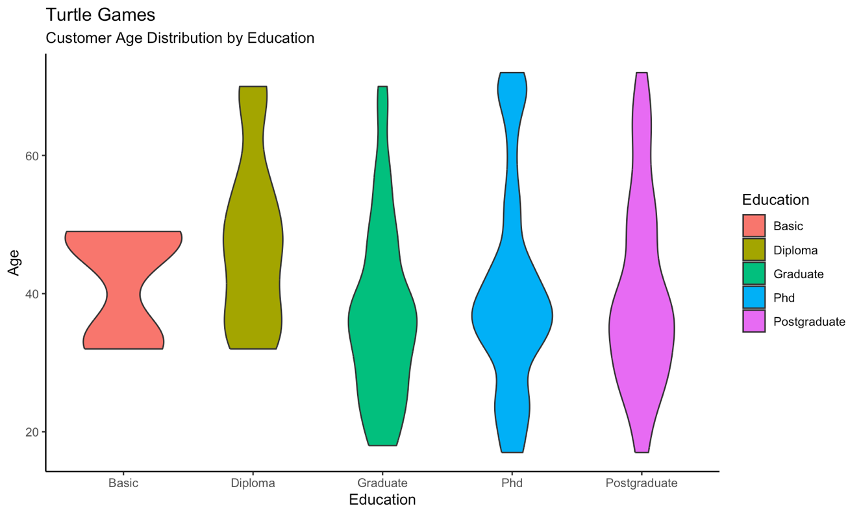

##### Spending Score

No major visible difference between the distribution of Male and Female customers, they more or less follow the same pattern.

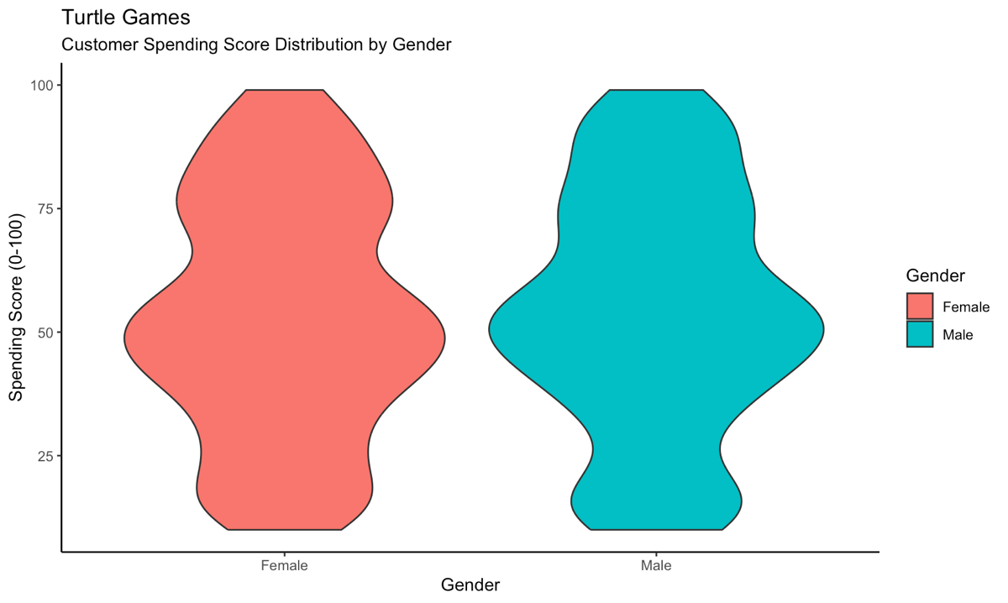

A bigger proportion of the higher-education customers have higher spending scores compared to customers with basic educational levels.

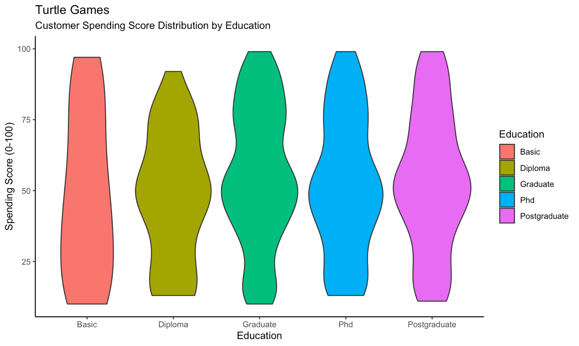

##### Annual Remuneration

The variation in annual remuneration doesn’t differ significantly between genders; they more or less follow the same patterns.

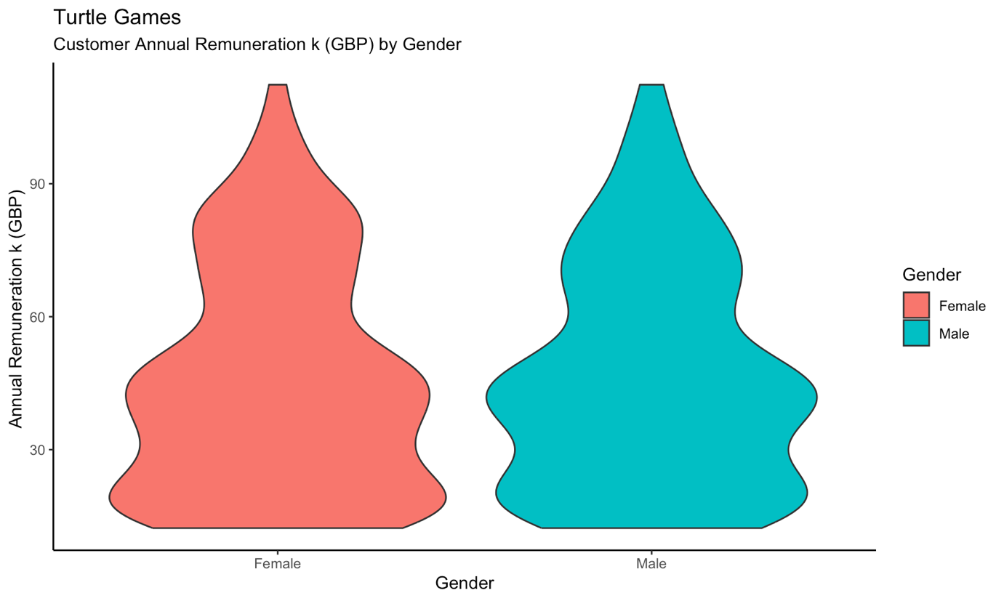

Customers with a basic education make up the largest portion of those earning above 60k annually; other customers with other educational levels are concentrated in lower income brackets.

**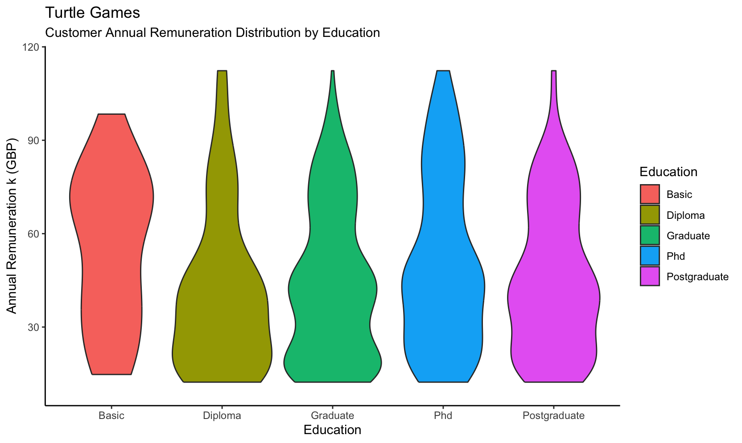****Outlier Analysis**

#### No outliers identified

Annual Remuneration and Spending Score Data exhibited no statistical outliers, with only one exception: a single high remuneration value in the remuneration chart. It was retained in the data as it didn’t appear erroneous.

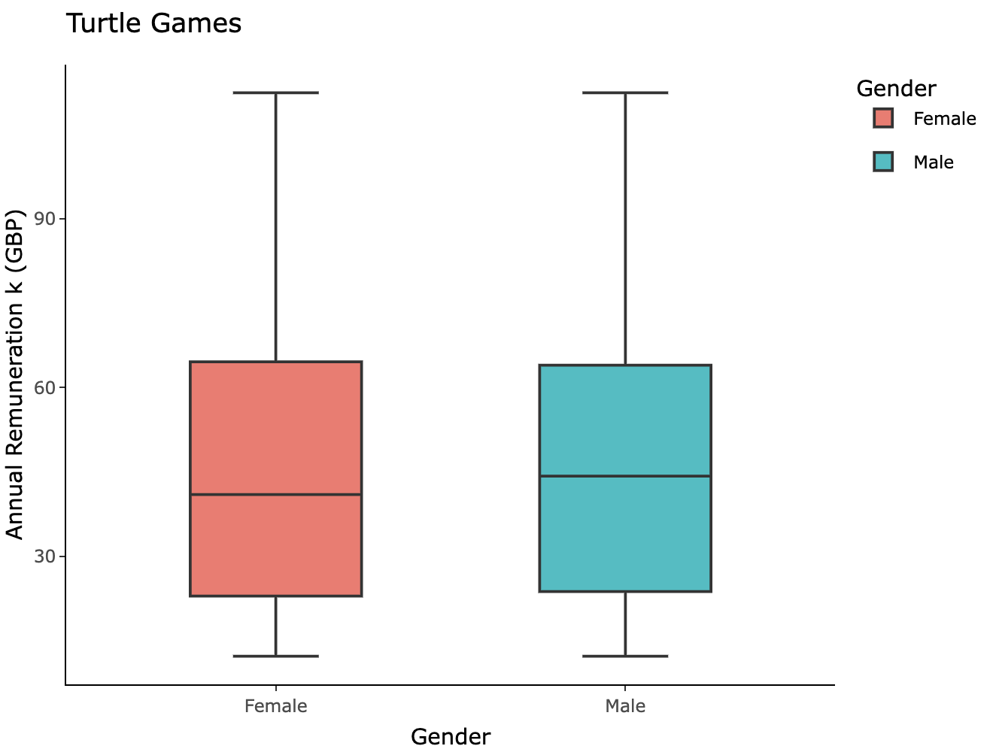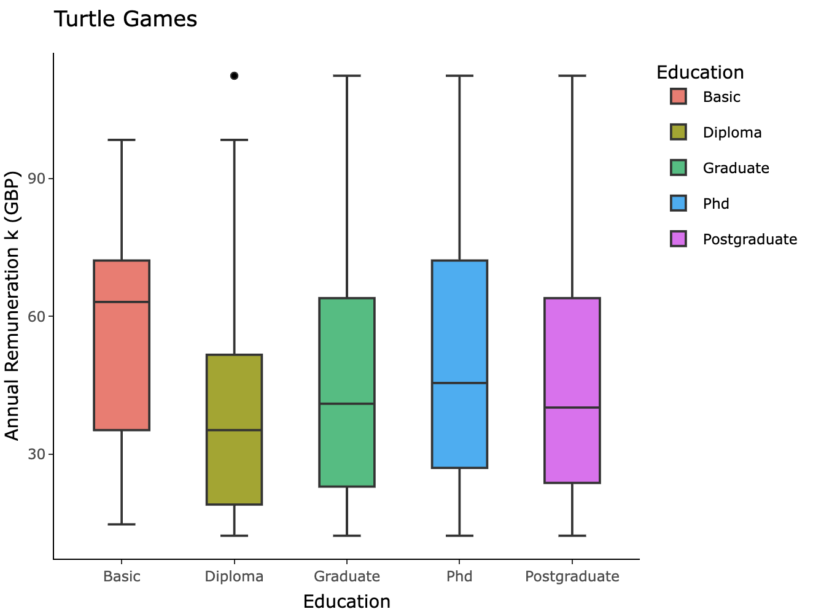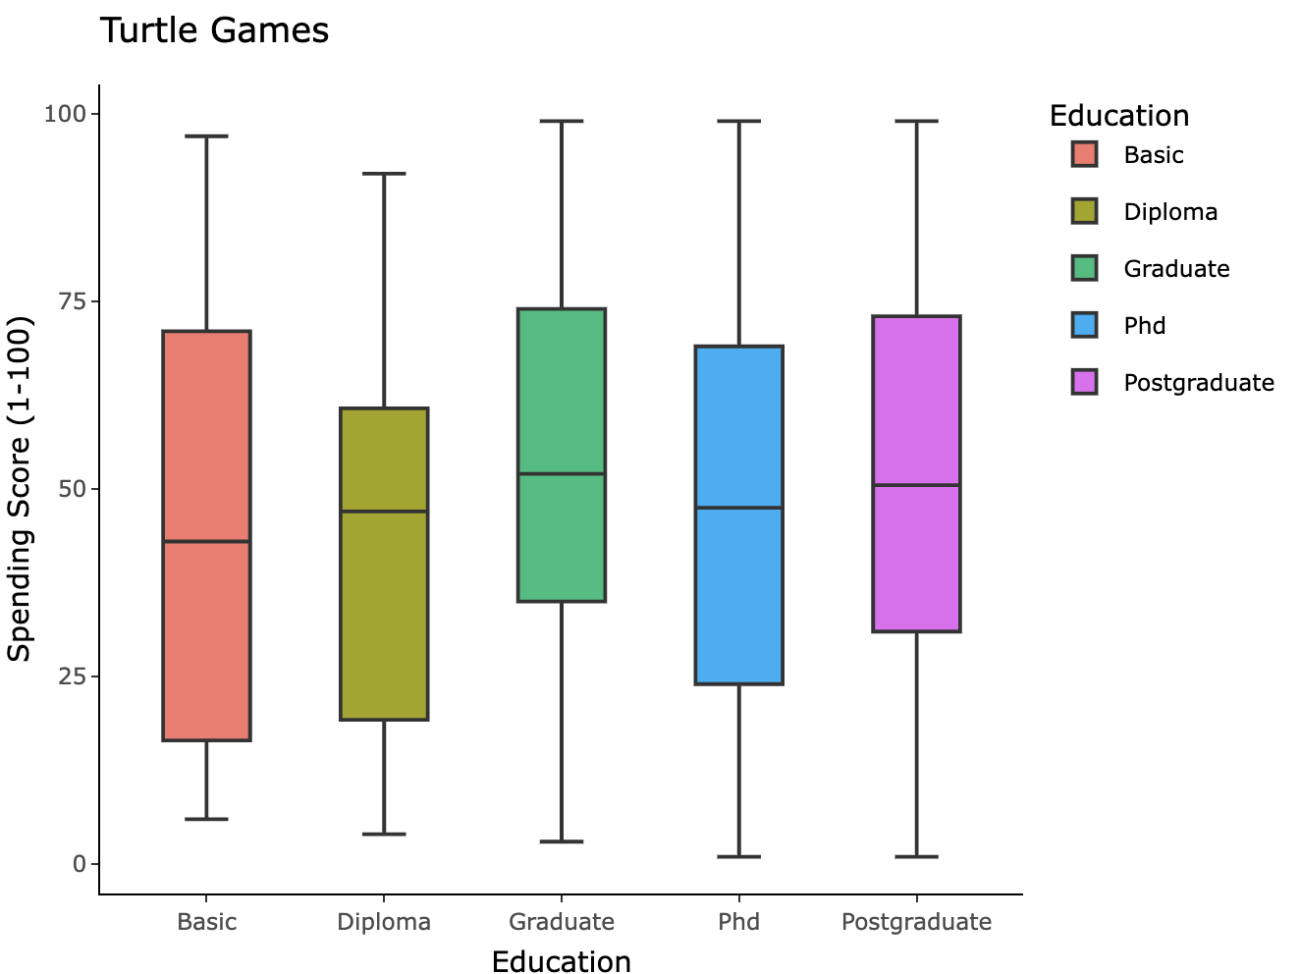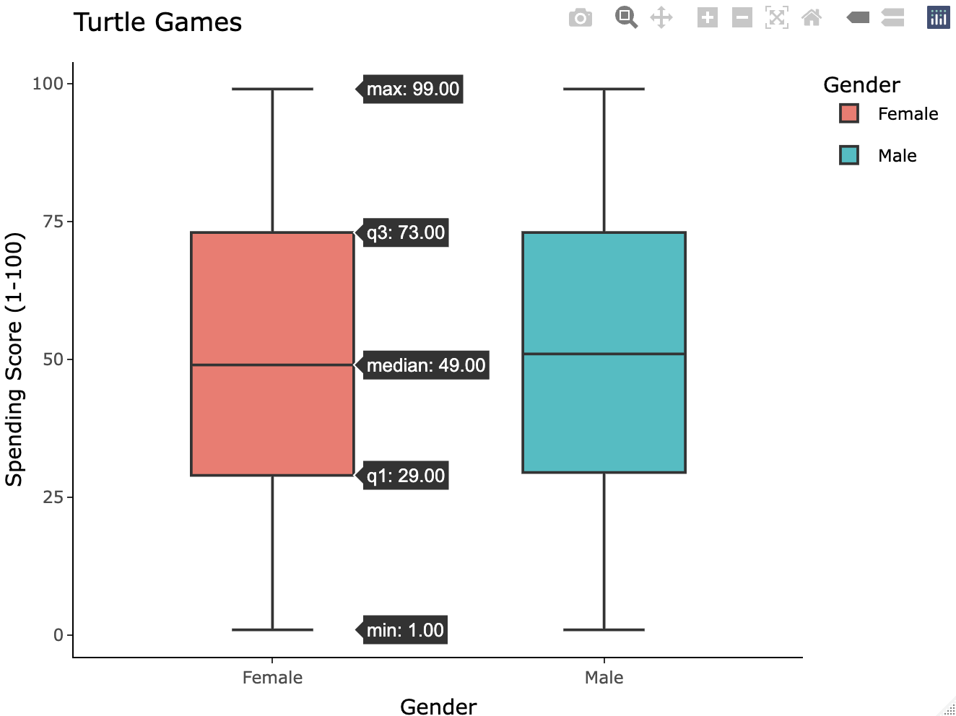

#### Identified outliers

Almost 12% of the customers have loyalty points that are considered statistical outliers. They were all, however, retained as they constitute a big portion of the data, and their presence reflects natural behavior common in loyalty programs.

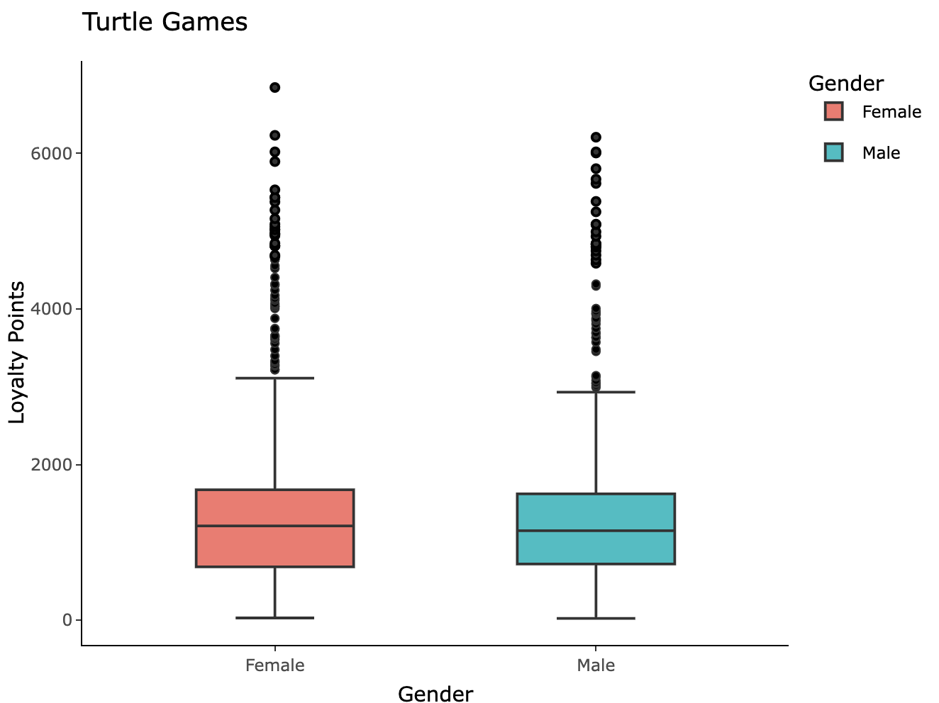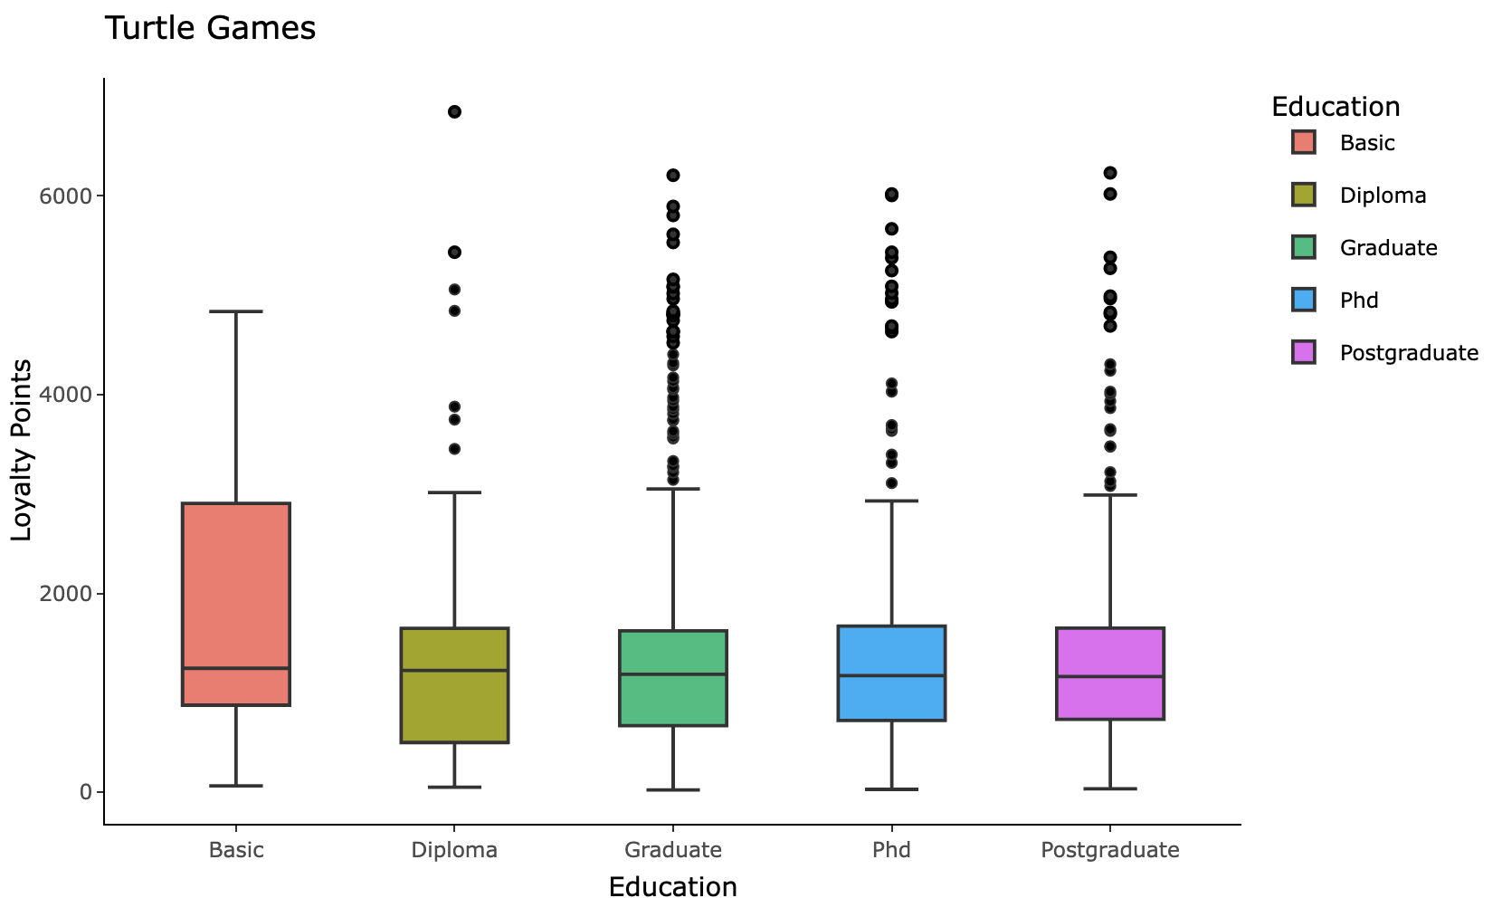

#### Simple Linear Regression

Linear Regression was considered as a preliminary model to predict loyalty points.

Simple linear regression models were built using spending score, annual remuneration, and age as independent variables.

All three models violated a key linear regression assumption, as heteroscedasticity is visible on all residuals’ charts.

In addition to heteroscedasticity, Loyalty vs Age violates the linearity assumption. R-squared for all models was also below 40%.

**Spending Score**

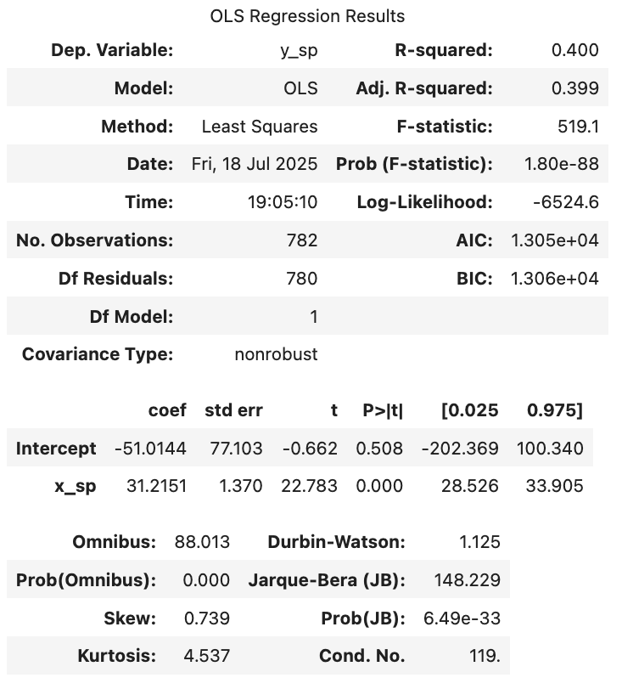

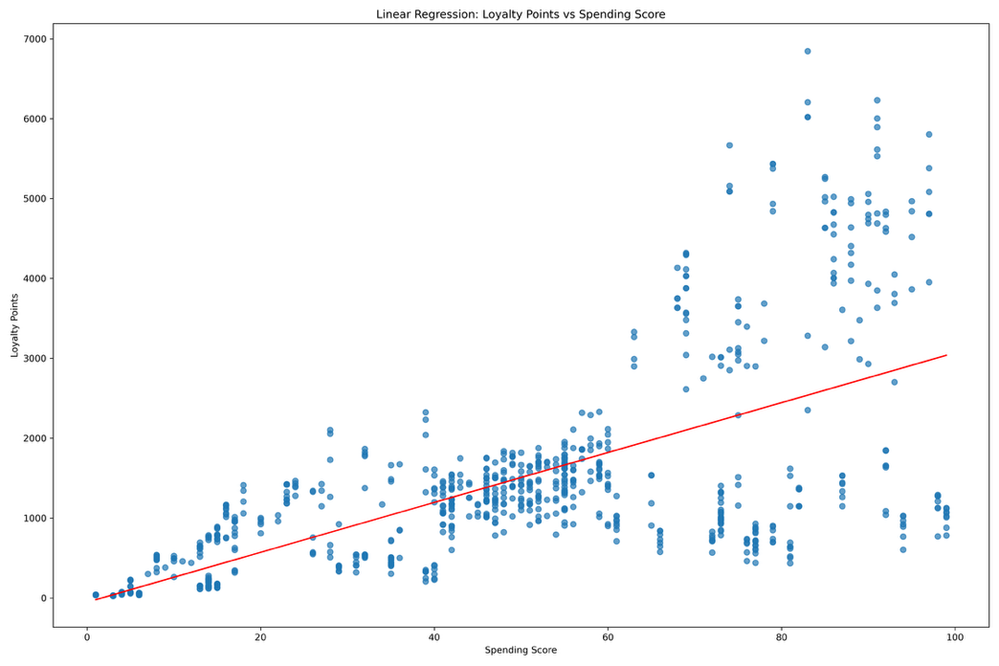 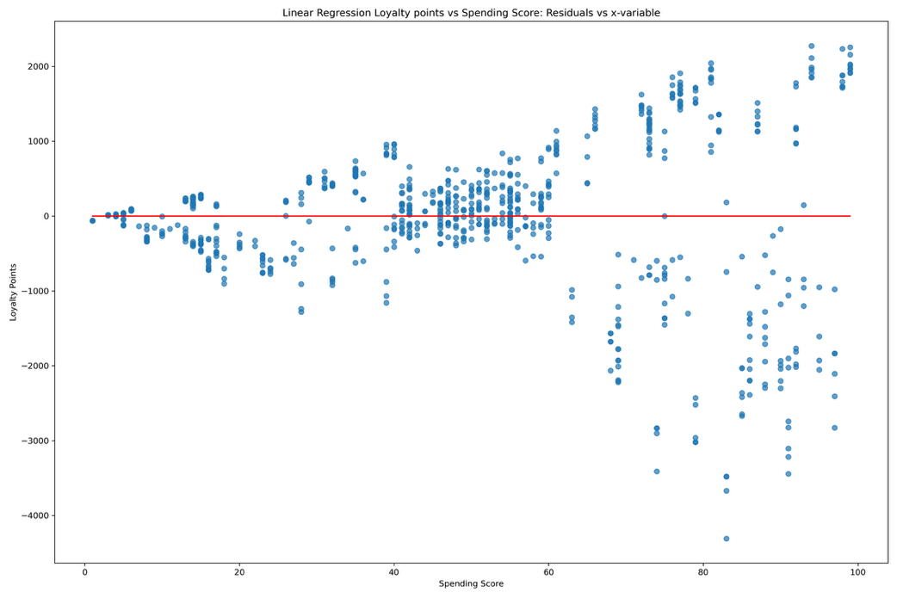

**Annual Remuneration**

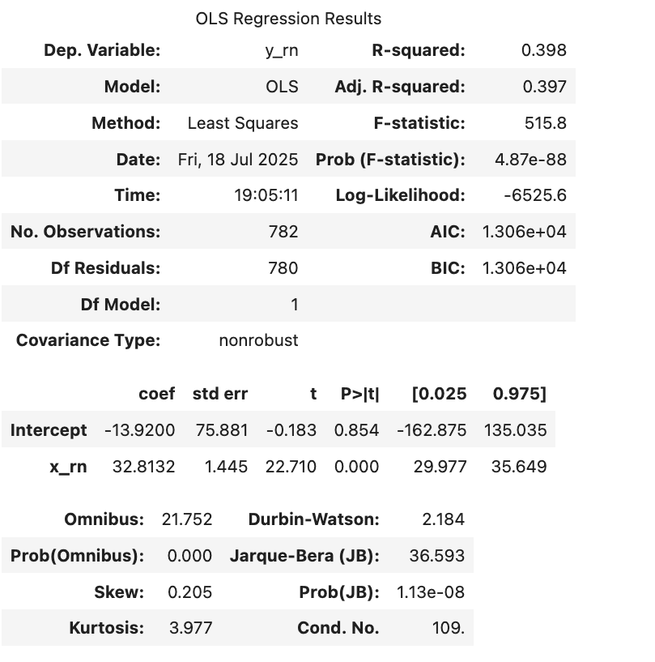

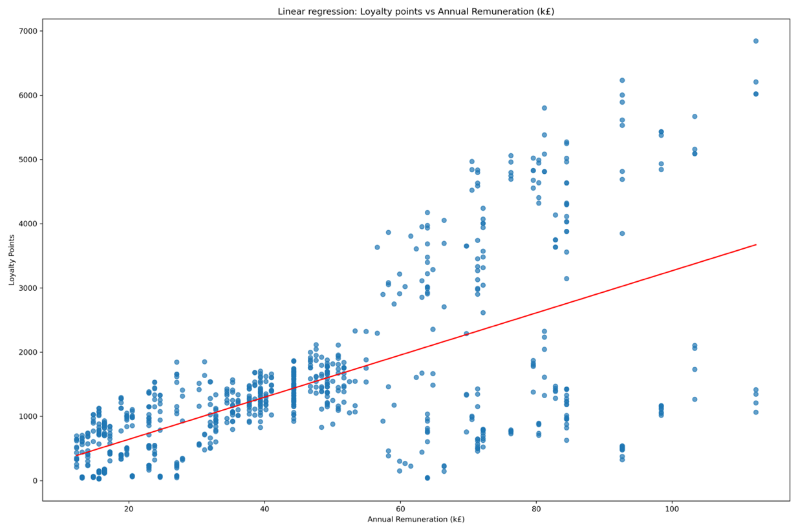 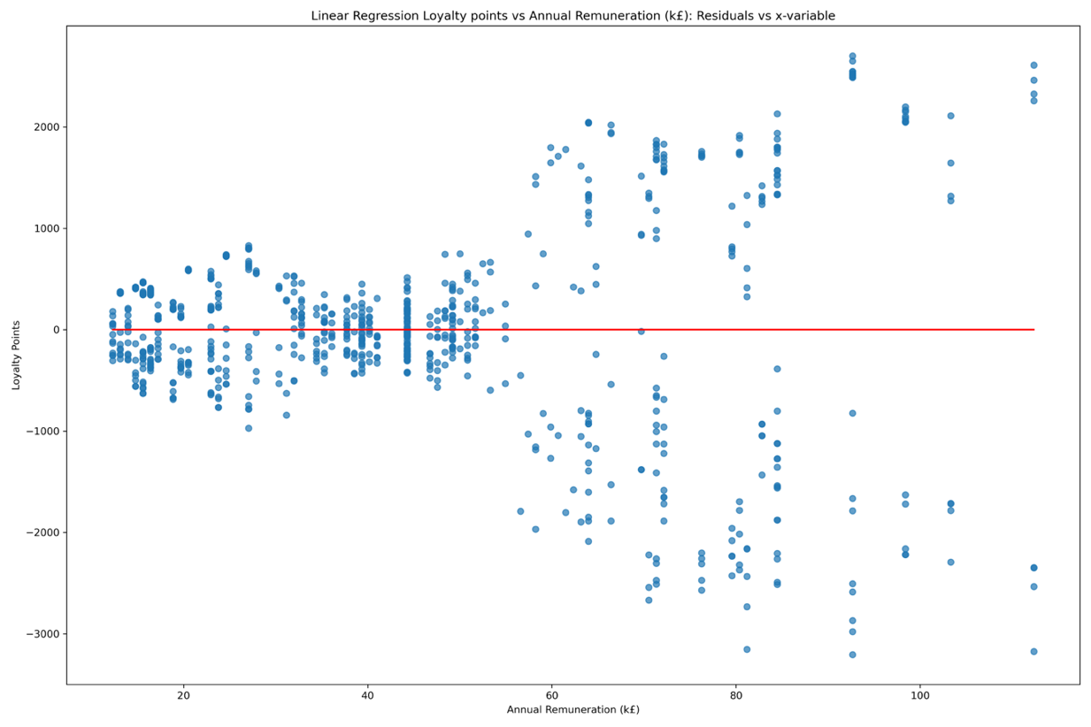

**Age**

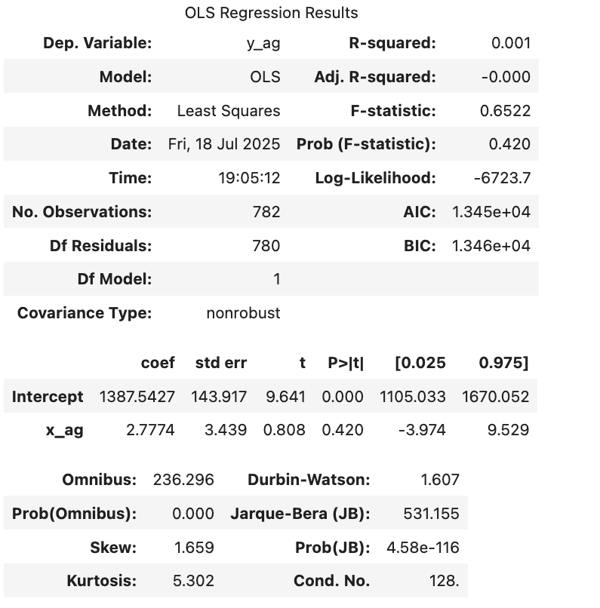

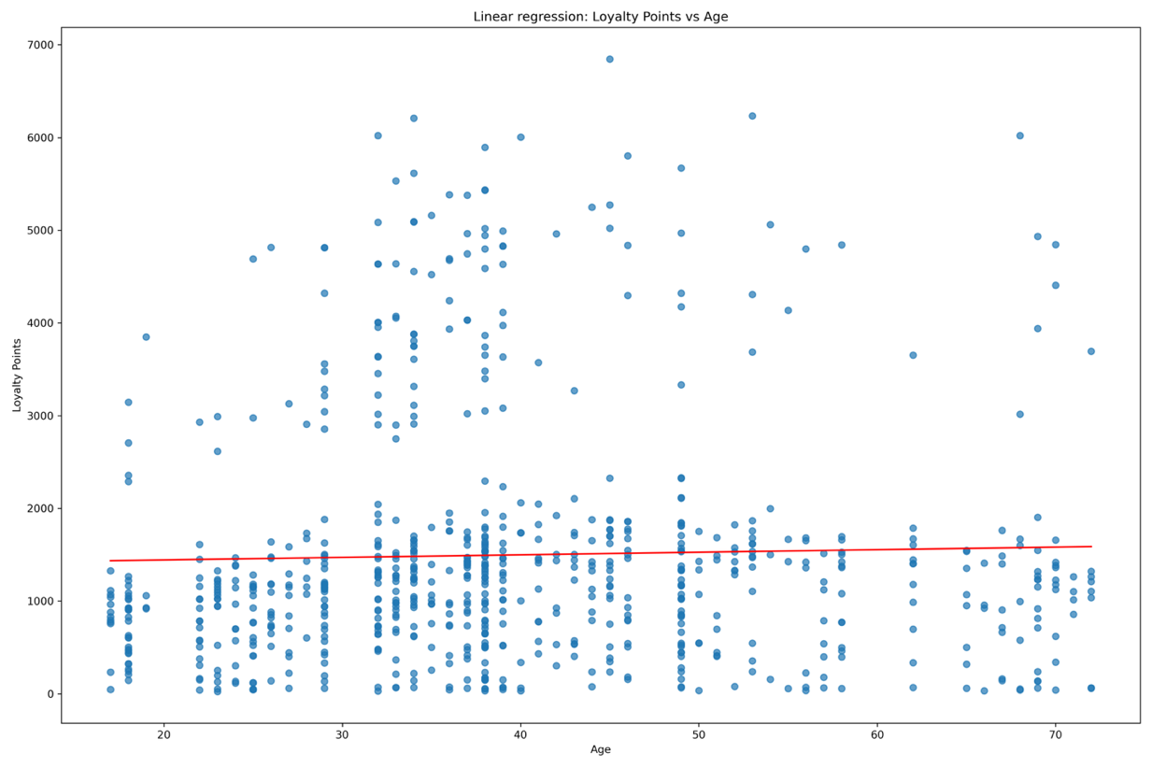

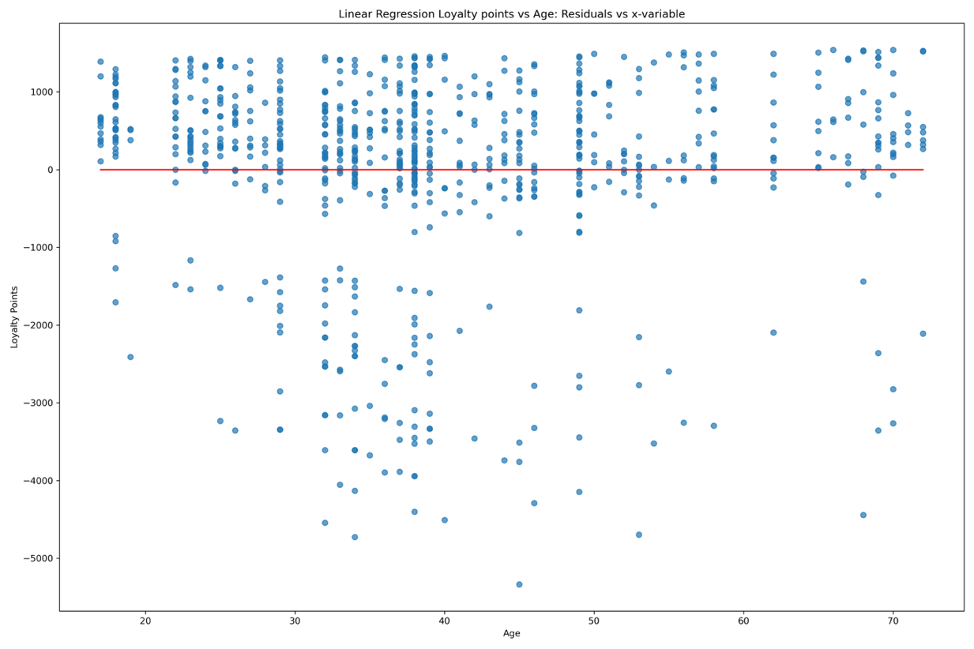

**Variance Inflation Factor**

In preparation for the multiple linear regression, the variance inflation factor was calculated for all three features to check the level of collinearity. Values for all 3 features and for the spending score vs annual remuneration are within acceptable limits <5, indicating no significant multicollinearity.

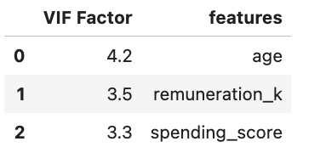

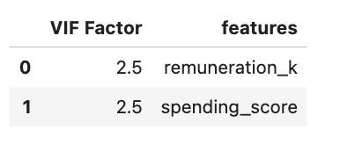

#### Multiple Linear Regression (MLR)

Five different multiple linear regression models were considered. One set including the age as a feature and one excluding it. Another set transforms the loyalty points by taking the square root.

Since linear regression is also sensitive to unscaled data, the data was scaled in R, and a fifth model was built for the loyalty points vs Annual Remuneration and Spending Score. All models showed improvement in the R-squared values compared to the simple linear models.

They all, however, violated key linear regression assumptions, such as normality of the residuals and homoscedasticity, suggesting that the models’ results are unreliable in predicting the loyalty points.

#### MLR (Age, Annual Remuneration, Spending Score)A graph of a graph with blue dots AI-generated content may be incorrect. A graph showing a line with blue dots AI-generated content may be incorrect.A graph with a red line AI-generated content may be incorrect.

**

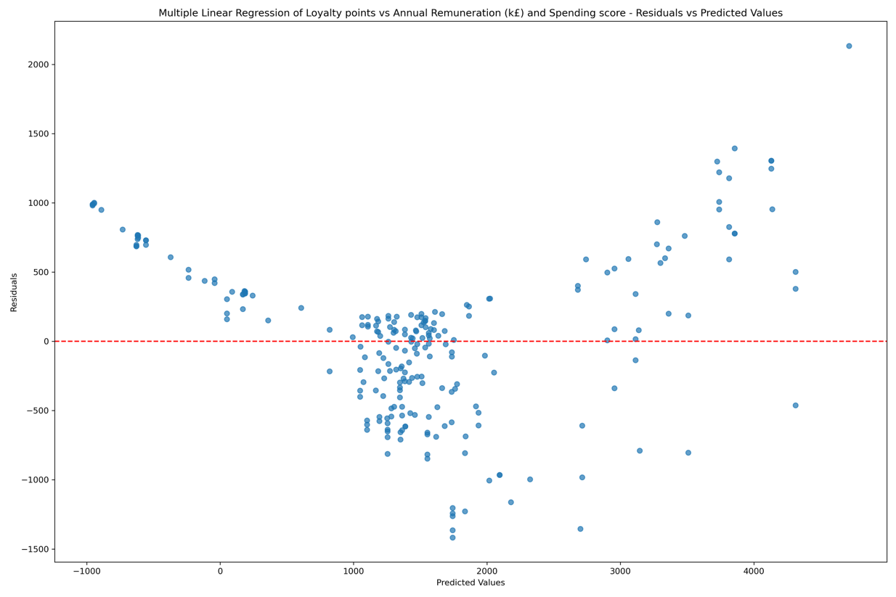

#### MLR (Transformed Loyalty points (Square Root) vs Age, Annual Remuneration, Spending Score)

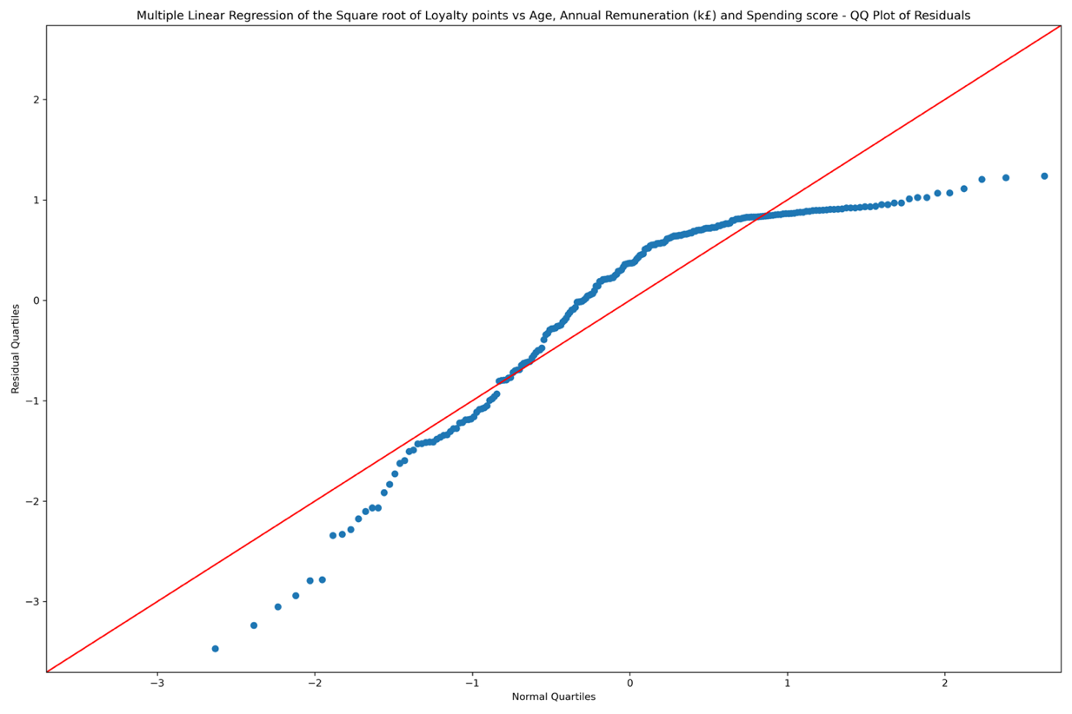

#### MLR (Transformed Loyalty points (Square Root) vs Annual Remuneration, Spending Score)

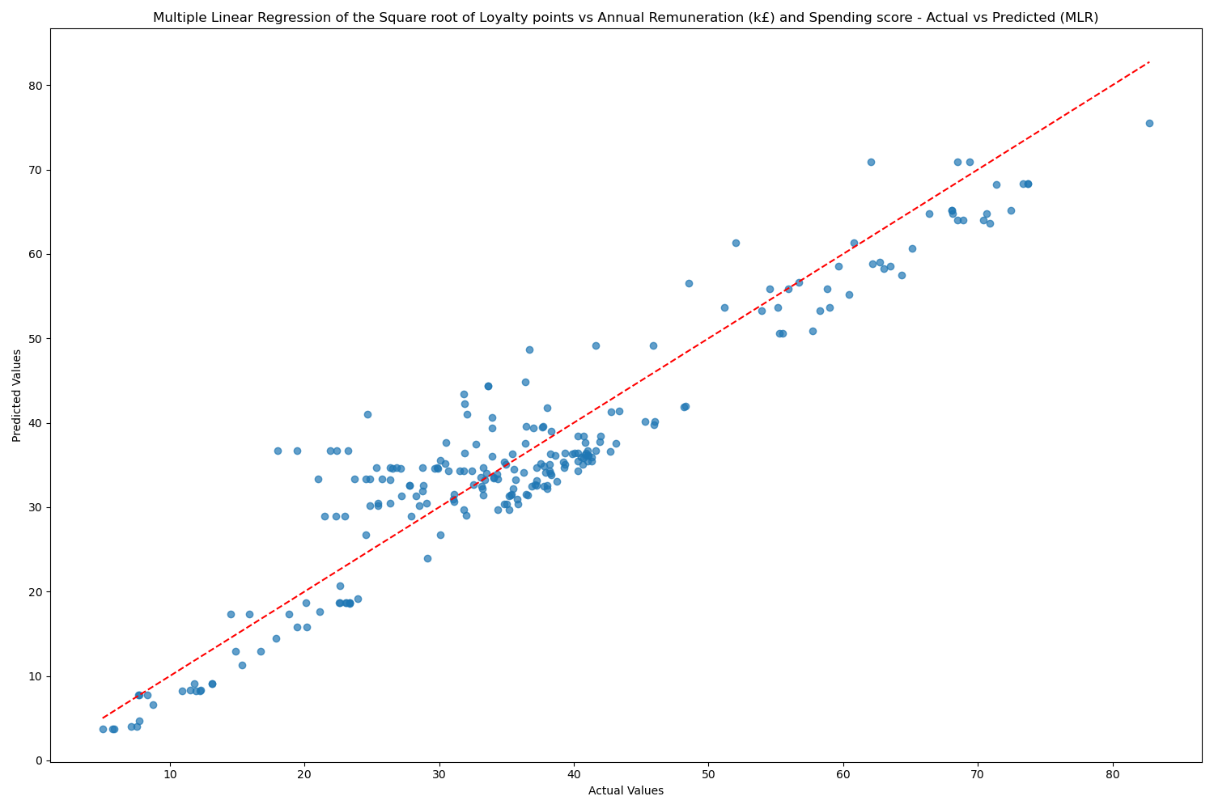 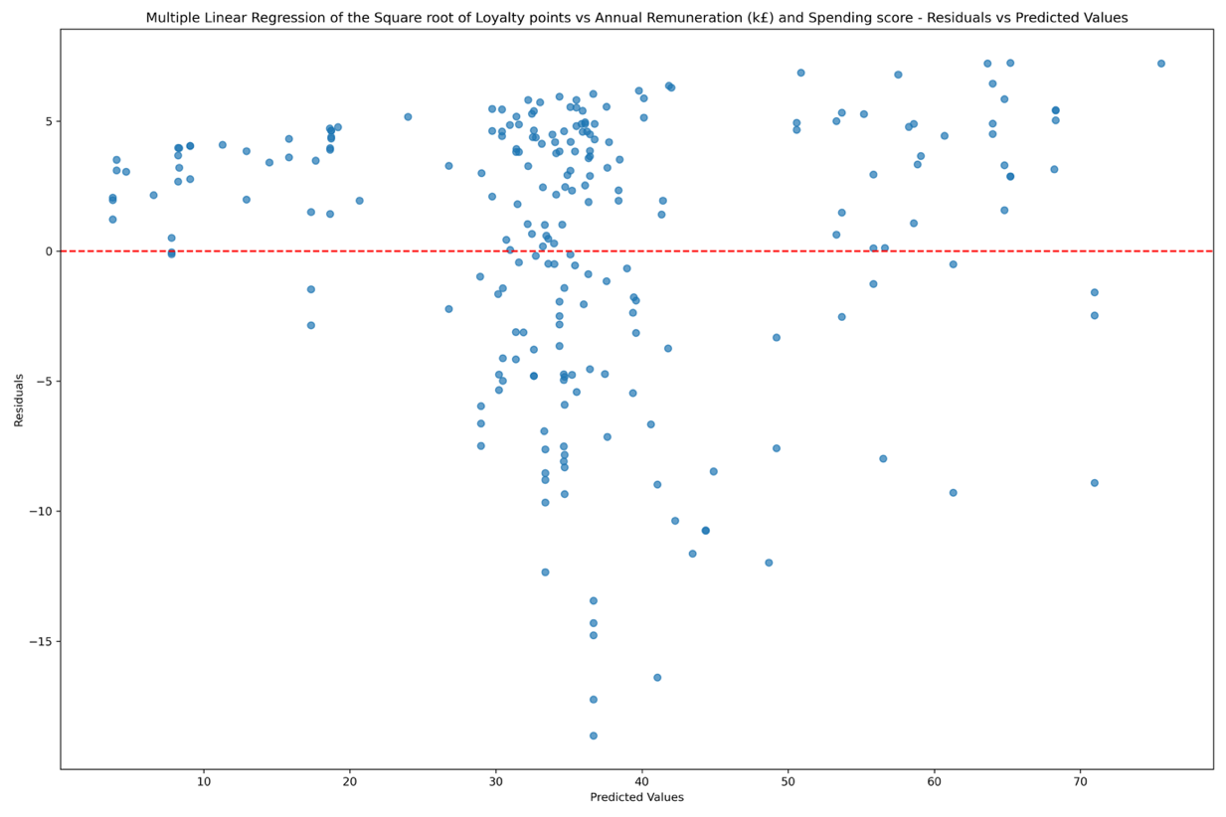

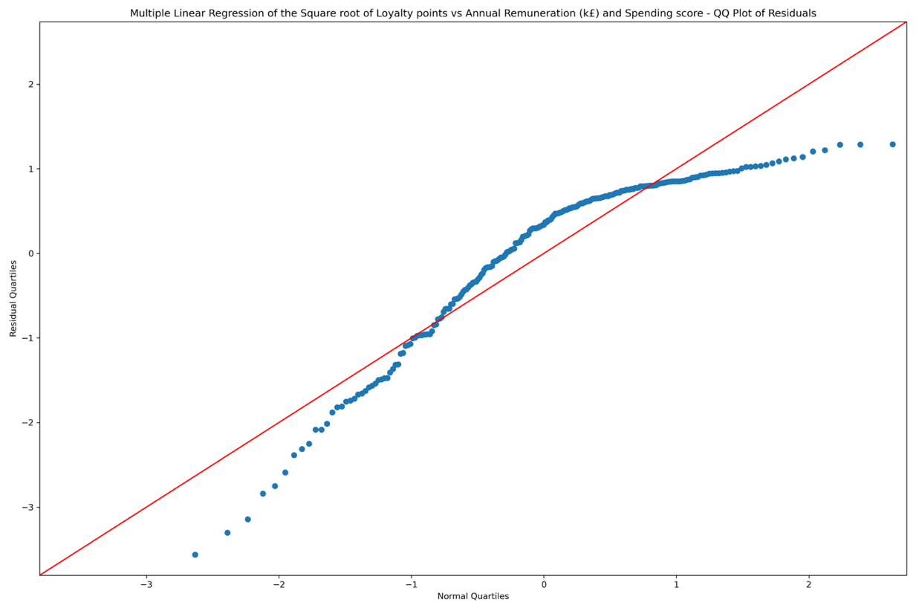

##### Scaled Multiple Linear Regression Model

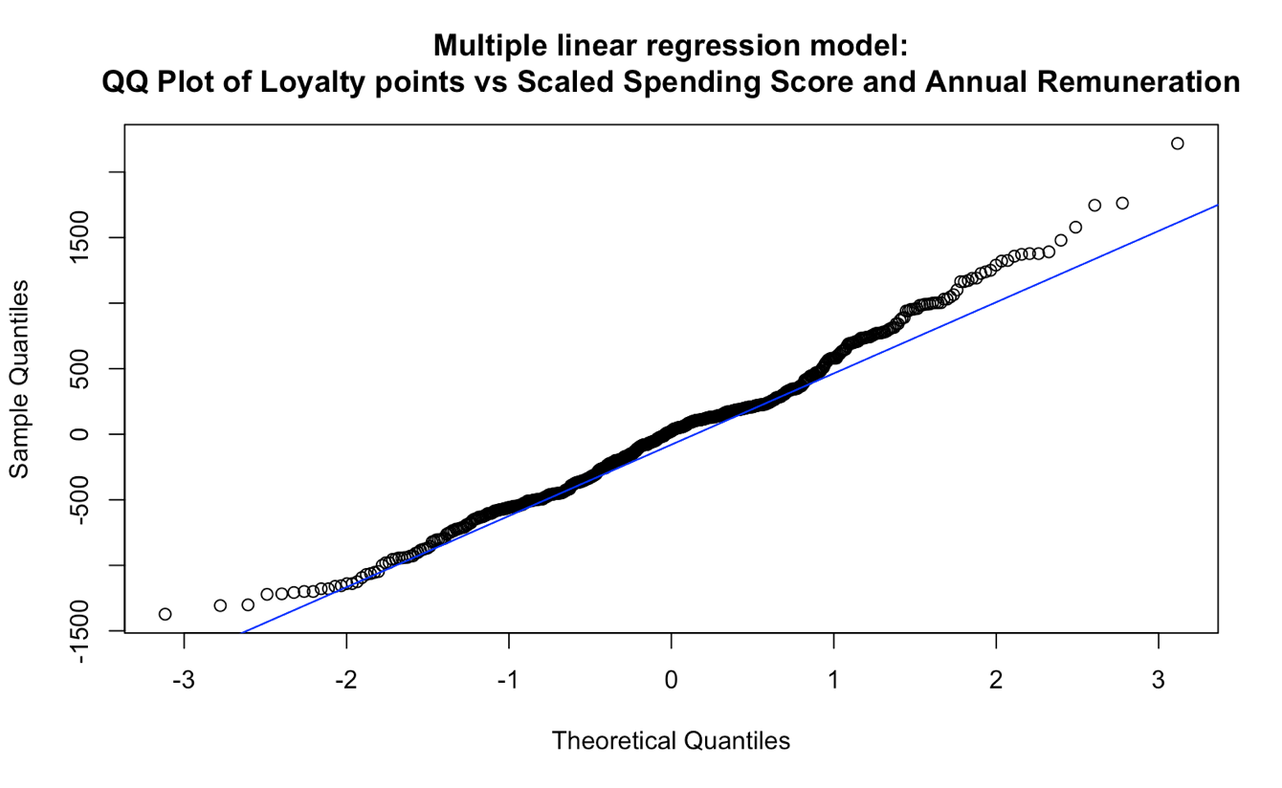

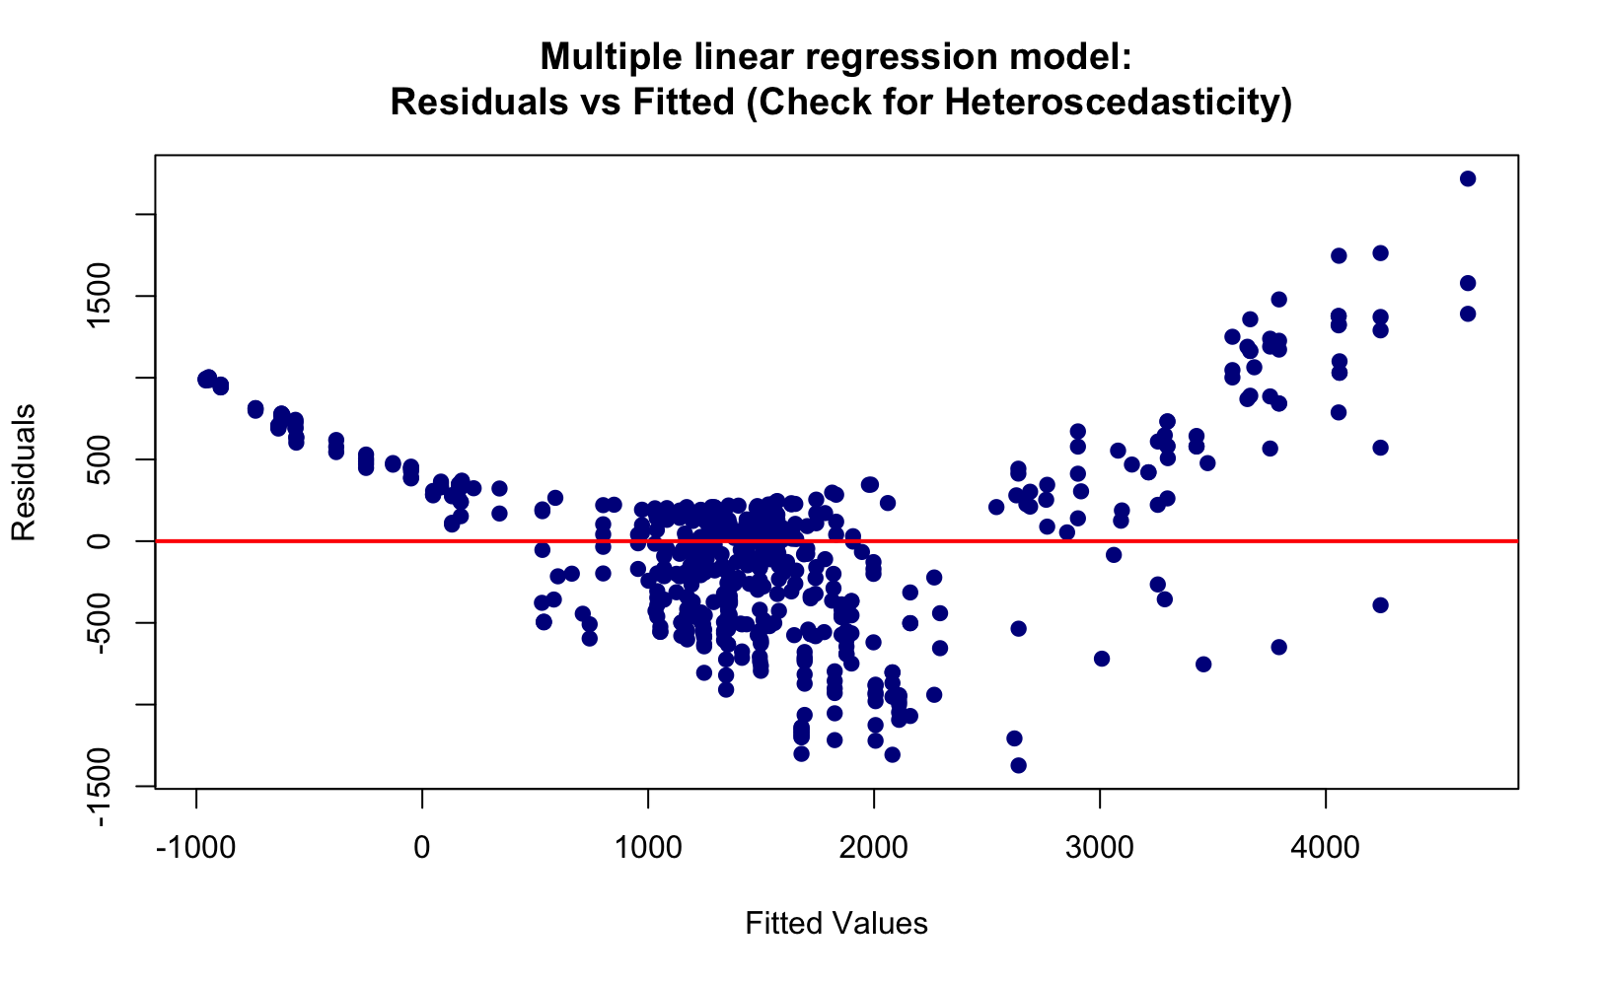

#### Decision Tree / Random Forest Regressor

Decision Trees and Random Forests are stronger, more advanced models and are not sensitive to the same assumptions of the linear regression model.

To prep the data for them, dummy variables were created for the following categorical variables:

* Gender
* Education

The following sequence was followed:

* An original tree was created with no restrictions
* Results were evaluated, and over-fitting was suspected
* Feature importance was evaluated to determine the features to be included
* R-squared score vs Tree depth was plotted to identify the ideal tree depth for pruning
* The pruned tree was created based on a maximum depth of 9

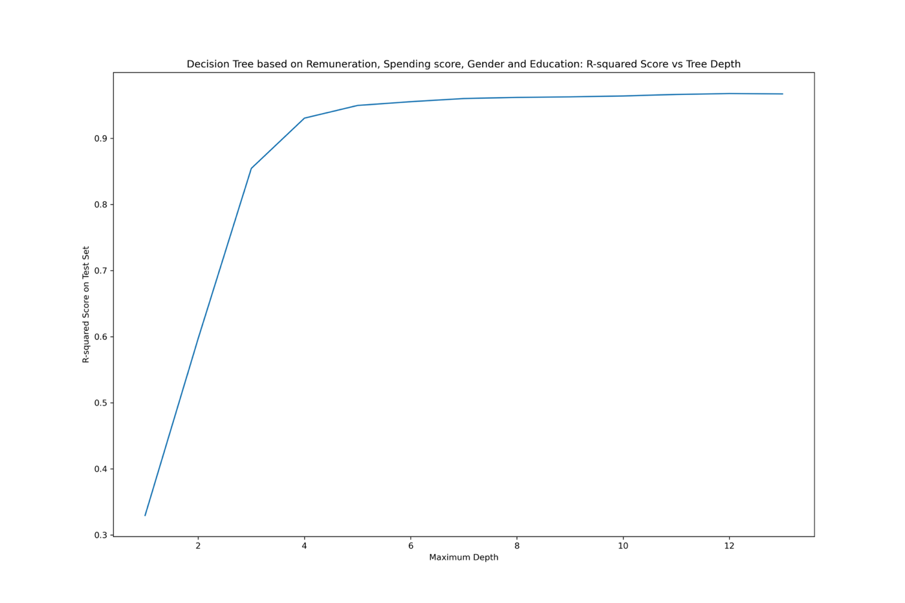

* Features with low importance were removed, and the results of the pruned tree were re-evaluated
* Evaluation metrics were assessed for all the models. This includes R-squared, MAE, and RMSE

**Pruned Tree Results – Before removing features with low importance**

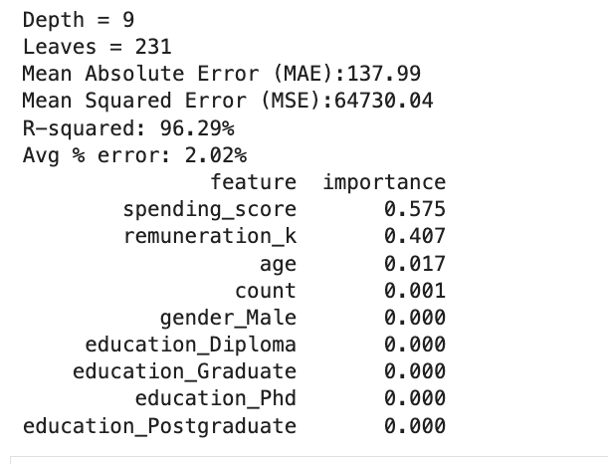

**Pruned Decision Tree Results** – **After removing features with low importance**

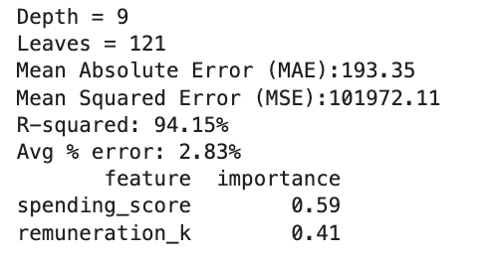

**Pruned Decision Tree Predicted vs Actual Values chart** after removing features with low 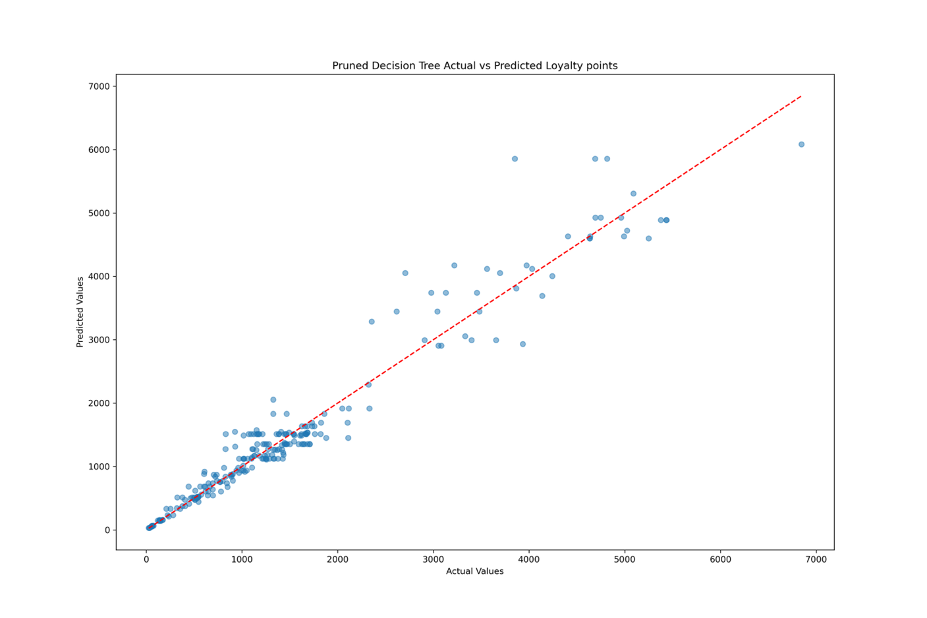

## Future Models – To Investigate

#### Hybrid Model – Cluster as feature regression – in R

Since the data has 5 visible clusters, an experimental model was built in R to test the power of adding clusters as features, along with the spending score and remuneration, to a random forest regressor.

The model produced satisfactory results and is deemed to better model the different behavior of the subsets in the data.

The limitation is, however, that clustering is an unsupervised model and is modeled on the whole dataset.

For real-world applications, where predictions for new customers have to be made, the following steps:

* The data has to be split into train and test datasets using stratified sampling to maintain the distribution of the data (7)
* The classification model will need to be leveraged to predict the clusters of the new data
* The predicted clusters will then be used as features in the regression model along with spending score and remuneration.

Given the time constraint, the model was considered but not built.

It can be done in the second phase of this project to explore the power of having such an advanced model.

A drawback of such a model is, however, the risk of error propagation from the clustering into the regression model.

It is, however, still interesting to investigate as it takes the different attributes of the clusters into account.

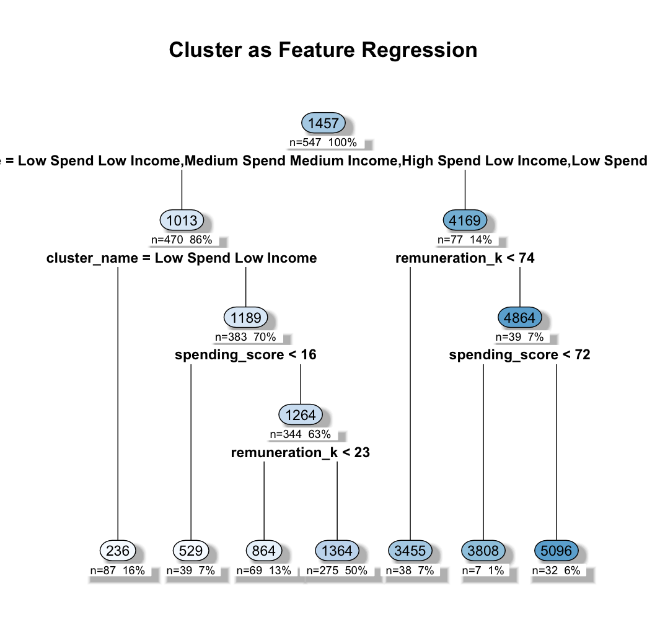

## Natural Language Processing

**Methodology**

The logic behind the natural language processing followed the following sequence:

**A. Product and Product Categories**

First reviews and summaries were grouped by product number. This means that all reviews and summaries belonging to the same product number

were joined together. They were then tokenized, lemmatized, and stop words were removed along with extra keywords that were found to be redundant, and a document term matrix (DTM) was then built.

The most common categories were then collected and categories were assigned to the products based on the keywords in the reviews. While not 100% accurate, assigned categories still give a sense of the categories that dominated the reviews, and where Turtle games need to collect more reviews to have a more representative sample.

Polarity and subjectivity were then calculated per product, and the median of both scores was calculated to assign a polarity and subjectivity score per product category

Charts were then created to show the top and lowest 20 products by polarity score. This is particularly useful for Turtle Games to identify problematic products.

Plots were then created for the top and worst 20 products based on polarity scores.

**B. High Loyalty Customers' Sentiment Analysis**

This analysis is extremely valuable in identifying customers with negative sentiment to proactively address their concerns. It is also valuable to identify the customers with positive sentiment to further engage them through the company's marketing efforts.

**C. Reviews and Summary Analysis**

Other than the analysis per product, product category, and the sentiment analysis of high-loyalty customers, a global assessment of the reviews and summaries was also created.

**Word Clouds:**

- Word clouds were first plotted for summaries and reviews including the stop words

- Stop words were then removed, and updated word clouds were replotted

**Top 15 Keywords**

- Top 15 keywords were plotted for the reviews and the summaries on a horizontal bar plot

- While Word clouds are interesting representation of the most frequently used keywords, they may not be as clear as the bar plot with the top keywords.

**Top 20 Positive And Negative Summaries and Reviews**

A list of the top 20 positive and negative summaries and reviews was created to carefully identify the main concerns in the negative reviews and maintain the positive points in the positive ones.

**Summary Word Cloud**

Duplicates were not removed in the case of the summaries as they didn’t seem erroneous and was deemed required to see the pattern of common keywords.

Five Sars, fun love, and great are among the top keywords.

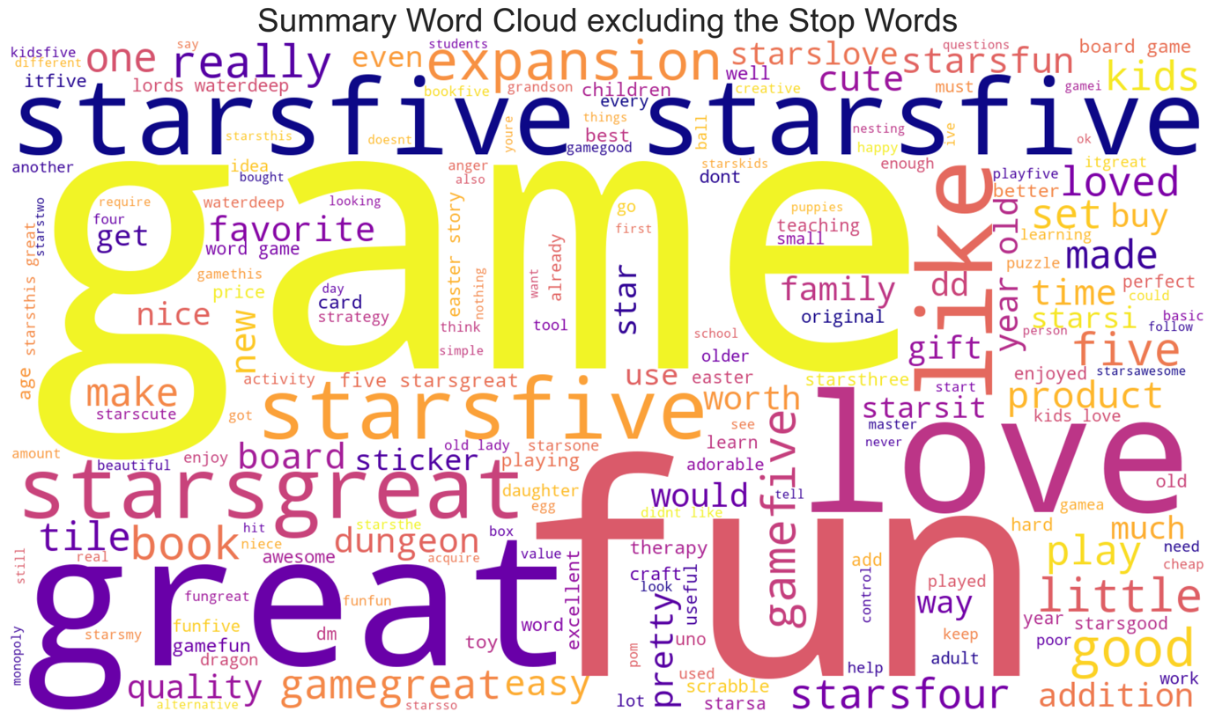

The most common keywords give a deeper insight into the pattern of keywords. Games is the most dominant keyword in both reviews and summaries, clearly identifying Turtle Games as a games producer and retailer.

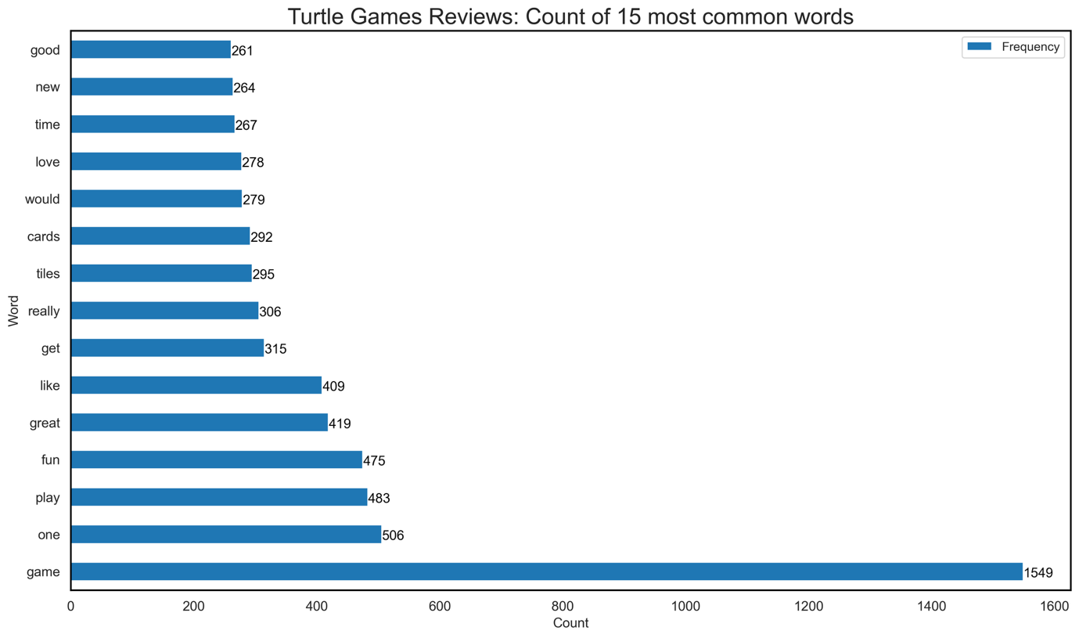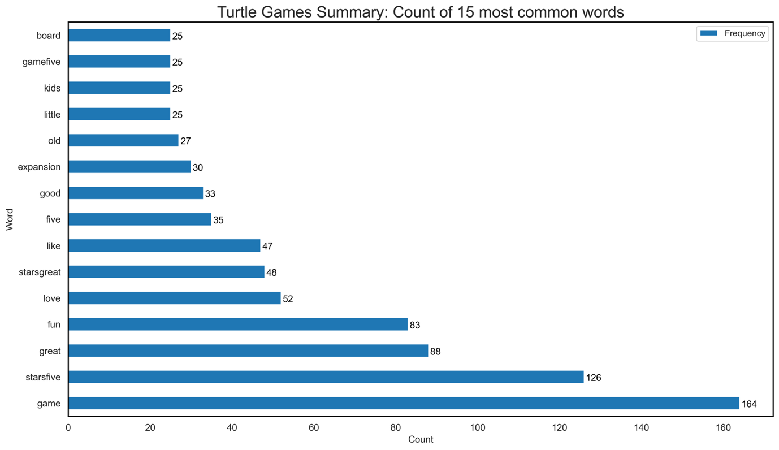

**Final Conclusions**

* Overall, turtle games have positive sentiment reviews and summaries. This indicates the general satisfaction of the customers with the company's product portfolio. A proactive approach towards negative sentiment products and customer reviews would help the company's image and would deepen the customers' loyalty and engagement with the brand.
* The analysis of the reviews and summaries was, in general, insightful as it clarified the reason behind the presence of senior (age-wise) customers. Many of the reviews included the words gift, grandkids, granddaughter...etc clearly explaining the presence of this age bracket.
* Senior customers can be targeted with seasonal offers and discounts around holidays to allow them to keep buying gifts for their loved ones at Turtle Games.

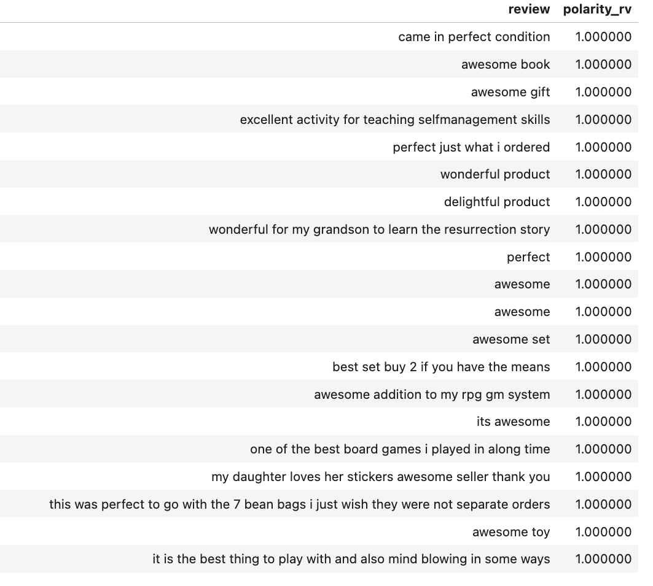

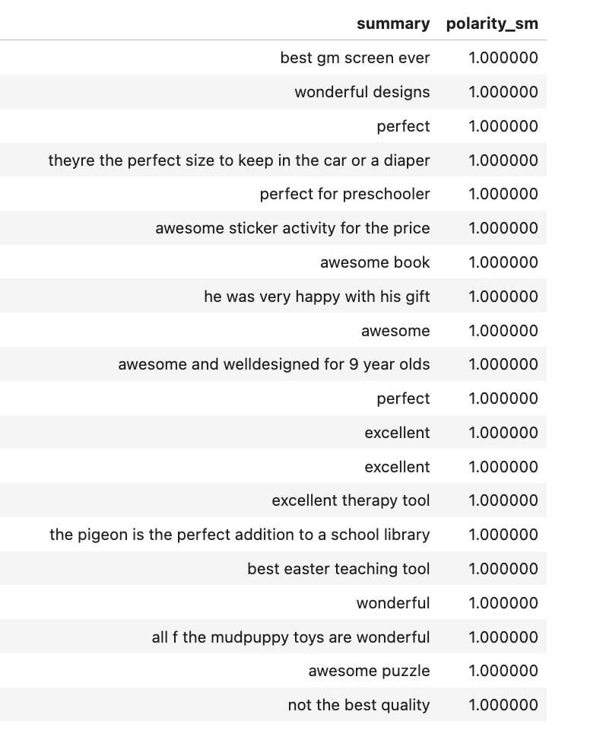

#### Works Cited

# Works Cited

1. ***Scikit Learn.* [Online] https://scikit-learn.org/stable/modules/ensemble.html#random-forests.**

**2. *helika.io.* [Online] Helika. https://www.helika.io/top-3-best-customer-loyalty-programs-for-games/.**

**3. Perkins, Carina. Emarketer. [Online] June 2023. https://www.emarketer.com/content/uk-loyalty-programs-2023.**

**4. Emarsys. *emasys.com.* [Online] October 2024. https://emarsys.com/learn/blog/customer-loyalty-statistics/.**

**5. Zinrelo. *zinrelo.com.* [Online] Zinrelo, July 2023. https://www.zinrelo.com/blog/customer-loyalty-program-metrics/.**

**6. Scikit Leanr. *scikit-learn.org/.* [Online] 2025. https://scikit-learn.org/stable/modules/generated/sklearn.model_selection.StratifiedShuffleSplit.html.**

**7. Ed Crouch, Ben Eppler, Lauren Taylor, Christina Mühlenbein, and Elizabeth Hearne. Boston Consulting Group. *bcg.com.* [Online] December 2024 . https://www.bcg.com/publications/2024/loyalty-programs-customer-expectations-growing.**

**8. —. BCG. *bcg.com.* [Online] Boston Consulting Group, December 2024. https://www.bcg.com/publications/2024/loyalty-programs-customer-expectations-growing.**

**9. Reinchheld, Fred. Bain. *bain.com.* [Online] Bain , September 2001. https://media.bain.com/Images/BB_Prescription_cutting_costs.pdf.**

**Cover Image**

**Karl Ibri [Online] Unsplash.**

**https://unsplash.com/photos/grayscale-photography-of-turtle-CQqZ2BWeoAU?utm_content=creditShareLink&utm_medium=referral&utm_source=unsplash**